Audio Harmonizer

Urinrinoghene Lauretta Omughelli

**Concept of Operations**

REVISION – Final Report

April 30th, 2022

**Change Record**

|  |  |  |  |  |
| --- | --- | --- | --- | --- |
| **Rev.** | **Date** | **Originator** | **Approvals** | **Description** |
| **-** | 9/6/2021 | Audio Harmonizer Team |  | Draft Release |
| **1** | 9/16/2021 | Audio Harmonizer Team |  | First Draft |
| **2** | 4/30/2022 | Audio Harmonizer Team |  | Final Revision |

**Table of Contents**

**1.** **Executive Summary** 10

**2.** **Introduction** 10

***2.1. Background*** 10

***2.2. Overview*** 11

***2.3. Referenced Documents and Standards*** 11

**3.** **Operating Concept** 12

***3.1. Scope*** 12

***3.2. Operational Description and Constraints*** 12

***3.3. System Description*** 13

***3.4. Modes of Operations*** 13

***3.5. Users*** 16

***3.6. Support*** 16

**4.** **Scenario(s)** 16

***4.1 Performing Live (Amateurs)*** 16

***4.2 Performing Live (Professionals)*** 16

**5.** **Analysis** 17

***5.1 Summary of Proposed Improvements*** 17

***5.2 Disadvantages and Limitations*** 17

***5.3 Alternatives*** 17

***5.4 Impact*** 18

**1.** **Introduction** 23

***1.1.*** ***Purpose and Scope*** 23

***1.2.*** ***Responsibility and Change Authority*** 23

**2.** **Applicable and Reference Documents** 24

***2.1.*** ***Applicable Documents*** 24

***2.2.*** ***Reference Documents*** 24

***2.3.*** ***Order of Precedence*** 25

**3.** **Requirements** 25

***3.1.*** ***System Definition*** 25

***3.2.*** ***Characteristics*** 26

**3.2.1.** **Functional / Performance Requirements** 26

**3.2.1.1.** **Range of 2-4 Overlaid Harmonies** 26

**3.2.1.2.** **Bluetooth Requirements** 26

**3.2.1.3.** **Functional GUI** 27

**3.2.2.** **Physical Characteristics** 27

**3.2.2.1.** **Mass & Size & Shape** 27

**3.2.2.2.** **Input & Output** 27

**3.2.2.3.** **Portable/Durable** 27

**3.2.2.4.** **Bluetooth Range** 27

**3.2.3.** **Electrical Characteristics** 28

**3.2.3.1.** **Inputs** 28

**3.2.3.1.1** **Power Consumption** 28

**3.2.3.1.2** **Input Voltage Level** 28

**3.2.3.1.3** **Battery Life** 28

**3.2.3.1.4** **Input Audio Sampling** 28

**3.2.3.2.** **Outputs** 29

**3.2.3.2.1** **Diagnostic Output** 29

**3.2.3.2.2** **Analog Output** 29

**3.2.3.3.** **Connectors** 29

**3.2.3.4.** **Wiring** 29

**3.2.4.** **Environmental Requirements** 29

**3.2.4.1.** **Thermal** 29

**3.2.4.2.** **External Contamination** 29

**3.2.4.3.** **Rain** 30

**3.2.4.4.** **Humidity** 30

**3.2.5.** **Failure Detection** 30

**3.2.6.** **Support Requirements** 30

**Appendix A: Acronyms and Abbreviations** 31

**1.** **Overview** 35

**2.** **References and Definitions** 35

***2.1.*** ***References*** 35

***2.2.*** ***Definitions*** 35

**3.** **Physical Interface** 36

***3.1.*** ***Weight*** 36

***3.2.*** ***Dimensions*** 36

**3.2.1.** **Dimension of subsystems** 36

***3.3.*** ***Mounting Locations*** 36

**4.** **Thermal Interface** 37

**5.** **Electrical Interface** 37

***5.1.*** ***Primary Input Power*** 37

***5.2.*** ***Microcontroller*** 37

***5.3.*** ***Audio Processing*** 37

***5.4.*** ***Analog-Digital and Digital-Analog Converters*** 37

***5.5.*** ***User Control Interface*** 37

**6.** **Communications / Device Interface Protocols** 37

***6.1.*** ***Bluetooth Communication*** 37

***6.2.*** ***Android Phone GUI*** 37

***6.3.*** ***MCU*** 40

**Subsystems Report** 41

1. Introduction 43

1. Subsystem 4: Power Supply 43

1.1. Introduction 43

1.2. Operation 43

1.2.1. Battery Charging Mode 45

1.2.2. Battery Not-charging/Discharging Mode 46

1.2.3. Battery Voltage Monitoring and I2C Communication Mode 46

1.2.4. Output Voltage DC-DC Conversion Mode 47

1.3. Validation 48

1.3.1. Battery Charging Results 48

1.3.2. Battery Not-charging/Discharging Results 51

1.3.3. Battery Voltage Monitoring and I2C Communication Results 54

1.3.4. Output Voltage DC-DC Conversion Mode Results 58

1.4. Conclusion 64

Subsystem: Android Application (In relation to Power Supply) 64

1.5. Introduction 64

1.1. Operation 64

1.1.1. Bluetooth Page 64

1.1.2. Home Page 65

1.1.3. Initial Inputs Page 66

1.1.4. Modes of Operation Page 67

1.1.5. Automatic Page 67

1.1.6. Manual Page 68

1.1.7. Start Singing Page 69

1.2. Validation 70

1.2.1. Navigation Bar 70

1.2.2. Manual Page 70

1.2.3. Application only connects to one device 72

1.2.4. Bluetooth Disconnection 73

1.2.5. Sending Data - User Inputs 74

1.2.6. Receiving Data - Battery Level 76

1.3. Conclusion 77

**Full System/InterSystem Report** 78

1. Introduction 80

2. MCU and Android App Bluetooth 80

2.1. Introduction 80

2.2. Execution 80

2.3. Validation 80

3. DSP and MCU I2C Communication 80

3.1. Introduction 80

3.2. Execution 82

3.3. Validation 82

4. Main PCB 82

4.1. Introduction 82

4.2. Execution 83

4.3. Validation 83

5. Main PCB and Power Supply 83

5.1. Introduction 83

5.2. Execution 83

5.3. Validation 83

6. Full System Description and Development 85

6.1. Overview 85

6.2. Execution 86

6.3. Validation 86

7. Conclusion 87

**List of Tables**

Change Record……………………………………………………………………………………....2

Table 2.3.1 Referenced Documents and Standards Links…………………………...……….7-8

**List of Figures**

Figure 2.2.1 Audio Harmonizer Overview…………………………………………………....…...7

Figure 3.1.1 System Description Diagram………………………………………………………..8

Figure 3.4.1 Manual Mode Input-Output Diagram………………………………………………10

Figure 3.4.2 Automatic Mode Input-Output Diagram…...………………………………………11

# **Executive Summary**

The Audio Harmonizer is a product that will revolutionize solo performances by introducing an affordable and easy to use system. Users can generate or build a series of harmonies through a mobile application which is used alongside a microphone and harmony generator to output multiple harmonies through a speaker in real time. The product utilizes signal manipulation to create harmonies from the user’s own voice. By combining converters, microcontrollers, and a mobile application, our team will create a system that produces a choir effect that can only be replicated by multiple pre-recorded voices. The following sections walk through a high level overview of the system as well as information regarding its use, users, and impact.

# **Introduction**

This document introduces a high level overview of our proposed Audio Harmonizer. The system will be composed of a blackbox with audio input and output that connects to a mobile application via bluetooth to generate harmonies in real time. The system will be capable of generating harmonies for a variety of chord progressions at any tempo as well as allowing composers to create their own harmonies on the mobile app. Users such as solo independent artists and those without the proper money or resources for proper equipment can use our application to create more complex art easily.

## ***2.1. Background***

With a rise in accessibility of producing and creating music, artists have been known to rise to stardom via free applications one can find on their phone such as Soundcloud, Tiktok, or Youtube. By creating technology that allows people to create music from their bedrooms, the music industry has transformed allowing those without the proper funding or resources a fair chance at success. Our team has come up with a product that will allow even the most inexperienced musicians to bring complexity and artistry to their work in a way that previously was far more exclusive.

The audio harmonizer is an application that creates a four part harmony in real time. By connecting the necessary equipment to your phone via bluetooth, the mobile app allows you to have control over what harmonies you wish to add or create from scratch. Simply connect a microphone to the input and a speaker to the output on the equipment, pick the mode of operation and either use the automated harmonies or create your own, choose the volume settings for each harmony, and set the speed of the song. Now, when you sing or play into the microphone, an output of up to four melodies will be heard as the lead melody is being played.

Existing plugins that create harmonies do exist, however, most of the harmonizers can create only two or three harmonies. In addition the more complex harmonizers are very expensive, costing up to $250 to use outside of a two week free trial. The plugins also only work with digital audio workstations (DAW). Good quality DAW can cost anywhere from $60 - $1000, which could be another cost that a small up and coming musician cannot afford. By making an affordable four part harmonizer that also can exist as a stand alone application, we are ensuring that independent artists can use our product to compose, produce, and perform.

## ***2.2. Overview***

Microphone

Amplifier

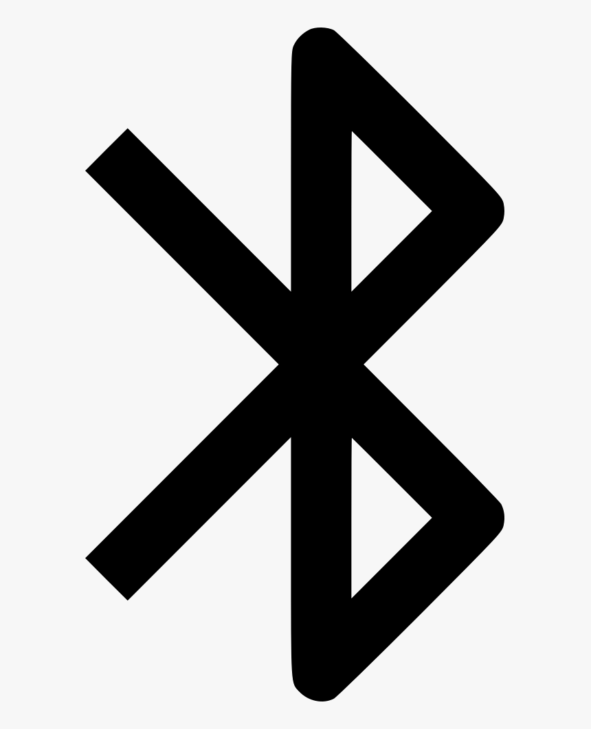

Harmony Generator

|  |
| --- |
| *Figure 2.2.1 Audio Harmonizer Overview* |

Our system comprises two major components, the mobile application and the harmony generator, as seen in Figure 2.1. The mobile application that allows the users to choose the harmonies and the tempo of the music. This information will be passed via bluetooth to the harmony generator.

The harmony generator takes an analog audio input from a microphone, converts it to a digital signal, uses the information passed down via bluetooth to generate the correct harmonies, and converts the new digital signal to an analog output which can be played through an amplifier.

## ***2.3. Referenced Documents and Standards***

|  |  |  |
| --- | --- | --- |
| **Section Referenced** | **Link** | **Date Updated** |
| 3.3 Digital Signal Processor | http://www.guitarpitchshifter.com/index.html | N/A |
| 3.3 Digital Signal Processor | https://www.ee.columbia.edu/~dpwe/resources/matlab/pvoc/ | 10/26/2010 |
| 3.3 Android Application | https://developer.android.com/training/basics/firstapp | 06/08/2021 |
| 5.2 Lithium Ion Battery | https://www.usaid.gov/energy/powering-health/technical-standards/lithium-ion-batteries | 6/30/2020 |
| 5.2 Power Supply Standards | https://www.osha.gov/laws-regs/regulations/standardnumber/1910/1910.269 | 10/5/2015 |

*Table 2.3.1 Referenced Documents and Standards Links*

# **Operating Concept**

## ***3.1. Scope***

This project is going to provide the equipment necessary to enable an individual to sing and develop a harmony of their choosing. This device will have a microphone as input where the signal will be processed through a Digital Signal Processor (DSP) and then be output to an amplifier. Additionally, it will be powered by a rechargeable lithium ion battery. The DSP will have bluetooth implementation to a phone application in which will control the user settings and store data. A system description diagram of the project is shown in figure 3.2

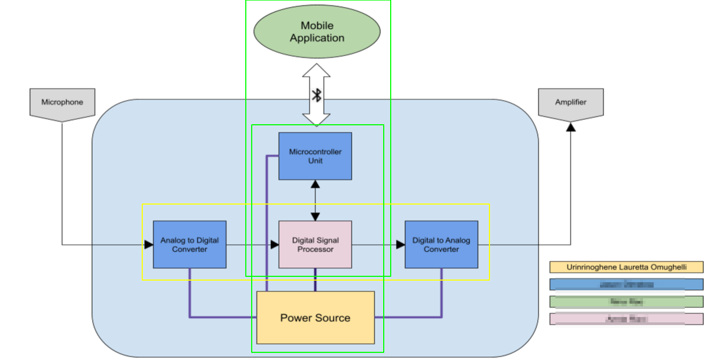

*Figure 3.1.1 System Description Diagram*

## ***3.2. Operational Description and Constraints***

The device will be used by musicians and hobbyists for music production and performance. In order to use the device a microphone must be plugged into the main unit consisting of the Analog to Digital Converter(ADC), the Digital Signal Processor (DSP), the Digital to Analog Converter (DAC), and the Multicontroller Unit (MCU). The battery life lasts 2-4 hours and the power supply provides 3.3V to the MCU,DSP, and rest of the PCB. At minimum, the user must have superficial understanding of chord progressions and tempo. The system functions only when the lithium ion battery meets the minimum battery life.

## ***3.3. System Description***

There will be five broad subsystems of our overall system as follows: Android application/bluetooth, DSP implementation, DAC/ADC converters, MCU, and the power supply/battery.

**Analog-Digital Converter and Digital-Analog Converter:** The ADC subsystem converts the analog input of the microphone into digital output for the digital signal processor to analyze. Furthermore, the DAC will take that processed data from the DSP and convert it into analog for the speaker to output.

**Digital Signal Processor:** The Digital Signal Processor will process an input digital signal from the ADC via the Microcontroller Unit and all necessary input generated in the Android Application via the Microcontroller Unit. Depending on the operation mode, the DSP will generate the proper digital signal for the harmonies using pitch shifting and a phase vocoder to create the final digital signal that is then output to the Microcontroller Unit.

**Android Application:** The Android Application will be the main user interface where the user can connect to the black box via bluetooth and then select between two modes of operation(automatic or manual). If the automatic mode is selected, the user will have to input the chord progression and the tempo. If the manual mode is selected, the user will select the notes for the harmonies they build.

**Power Supply:** The power supply will be in the form of a rechargeable lithium ion battery. It will power the harmonizer generator which includes the ADC, DSP, DAC and the MCU. Our goal is for the battery to power the system for a specified amount of time which will be finalized based on the specifications of the included hardware/circuitry.

**Microcontroller Unit:** The Microcontroller Unit will communicate with our other subsystems to enable smooth integration and operation of the harmonizer unit. This unit will also use bluetooth to communicate with the Android Application.

## ***3.4. Modes of Operations***

The Audio Harmonizer will have a pitch change and a built-in delay which can be used for two different modes of operations; namely- manual and automatic modes.

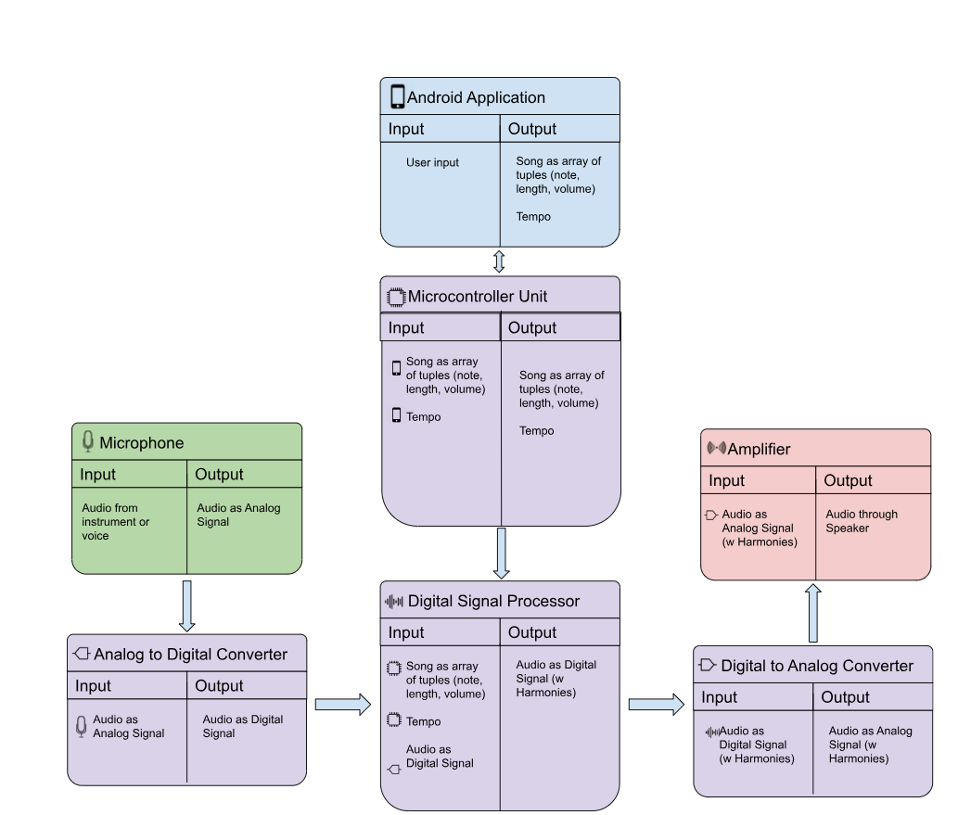

*Figure 3.4.1 Manual Mode Input-Output Diagram*

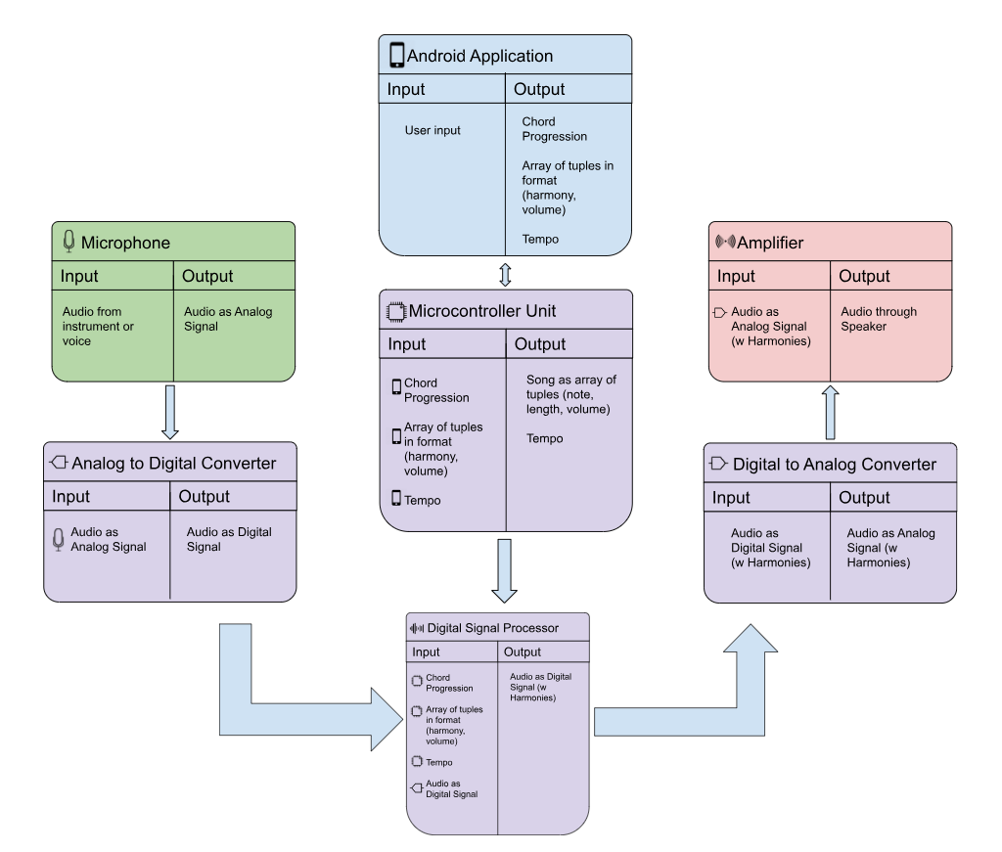

*Figure 3.4.2 Automatic Mode Input-Output Diagram*

**Manual mode:** This mode allows for manual note selections with time delays between each note through the app to enable change in pitch and give a desired melody based on the user’s selection. Once the desired pitches are selected, they are then stored in the app and can be replayed by the user.

**Automatic mode:** This is a mode in which harmonies are automatically matched to the melody input through the microphone. The performer sings into the microphone and after the analog signals have been converted to digital signals, the app changes the pitches to form an authentic musical note which is then processed, and immediately converted to output through the speakers. This mode is useful for live music performances done by amateurs in which the performer can give authentic performances with harmonies that are automatically selected by the app based on the chord progression chosen.

**Note:** Pitch changes are achieved by transforming the input frequency from the digital signal. Due to the process of changing the frequency, there will be a slight delay between the input melody through the microphone and the output set of harmonies played through the amplifier.

## ***3.5. Users***

The Audio Harmonizer will be a useful product for new and advanced musical artists; ranging from startup musicians to college students to professional music producers. The device can be used in a casual setting as a fun activity or in a more professional setting to compose music for production and release. As such, the level of training will be very minimal and will include instructions on how to use it. Similarly, the installation process will be simple- the users will hook up the microphone to one end of the black box and the speaker to the other end. At the production stage, the app can be downloaded from the app store with just a few clicks and will be easy to navigate with clear digital signage.

## ***3.6. Support***

Our device will have technical support and a user manual. First time use of the app will include a prompt of a 30 second tutorial on how to navigate the app and use its various tools. The app will also include a “help” section with a user manual to enable users to read instructions and find a list of Frequently Asked Questions (FAQ) with answers to those questions. Post app deployment, there will also be a help phone line provided for users to call and get immediate help for persistent/unresolved technical issues.

# **Scenario(s)**

## ***4.1 Performing Live (Amateurs)***

The primary use of the Audio Harmonizer would be to use this tool in a live performance setting. This could be used to shift pitch of the vocals to enhance live performances by creating a choir effect using a single input voice. Amateurs will most likely use the automatic mode of operation because it will create the harmonies for them. For example, a hobbyist performing at an open mic event can use the application to elevate their music.

## ***4.2 Performing Live (Professionals)***

The secondary use of the Audio Harmonizer would be to use the manual mode of operations, so the artist has complete control over the harmonies generated. By selecting notes on the mobile application, the user can create their own harmonies and develop a way to perform them without the need for additional musicians or prerecorded audio. For example, if a band only has one singer and they need multiple harmonies on a song, the Audio Harmonizer is the perfect solution.

# **Analysis**

## ***5.1 Summary of Proposed Improvements***

With the product our team wants to create a system that could improve upon the existing solutions for harmony creation. Listed below are examples of our system's advantages.

* The mobile application will allow for testing of new harmonies with ease.
* This system will be portable; the box will be light enough to be hand carried or transported in a backpack.
* The system will be a lot more cost efficient than the other existing software.
* This product allows for live harmony generation, whereas the software versions add harmonies post recording.

## ***5.2 Disadvantages and Limitations***

Due to time and monetary constraints, there are certain limitations and disadvantages that users could encounter. For example:

* The system requires the use of an android device, so iphone users will not be able to use the app
* The battery will need to be recharged so the system is limited to the life cycle of the battery
* The system needs to be used in conjunction with a proper microphone and speaker
* The automatic harmony generation doesn’t use machine learning

## ***5.3 Alternatives***

While our product is unique, there are similar devices and tools that also create solutions for harmony generations. There are also alternate methods to harmony creation.

* There are software systems that harmonize but users have to pay a certain amount of money per month. In the long run, our system would be more cost effective
* Users can manually record the harmonies before a live performance instead.
* In the studio, users can record each harmony individually, which takes more time and effort for producers and musicians.

## ***5.4 Impact***

This could potentially have a negative impact on the environment because of the raw materials being used. The system will use a lithium ion battery which historically negatively affects the surrounding environment. The extraction process of lithium uses a lot of resources and the mines required to extract the metal destroy ecosystems in Chile, where the majority is mined. Producing our product in bulk could contribute to climate change and water scarcity.

On the other hand, this system allows for young and underprivileged musicians to gain access to resources that were once very exclusive. Our society could potentially gain an influx in upcoming independent artists that otherwise would not be able to succeed in an industry that's notorious for being restrictive because of the high expenses that come with music production and performance. Our team hopes the accessibility that the Audio Harmonizer brings will foster new interest in music.

Audio Harmonizer

Urinrinoghene Lauretta Omughelli

**Functional System Requirements**

REVISION – Final Report

April 30th, 2022

**Change Record**

|  |  |  |  |  |
| --- | --- | --- | --- | --- |
| **Rev.** | **Date** | **Originator** | **Approvals** | **Description** |
| **-** | 09/29/2021 | Audio Harmonizer Team |  | Draft Release |
| **1** | 10/04/2021 | Audio Harmonizer Team |  | First Draft |
| **2** | 04/30/2022 | Audio Harmonizer Team |  | Final Revision |

**Table of Contents**

**Introduction 20**

1.1. Purpose and Scope 20

1.2. Responsibility and Change Authority 20

**Applicable and Reference Documents 21**

2.1. Applicable Documents 21

2.2. Reference Documents 21

2.3. Order of Precedence 22

**Requirements 22**

3.1. System Definition 22

3.2. Characteristics 23

3.2.1. Functional / Performance Requirements 23

3.2.2. Physical Characteristics 24

3.2.3. Electrical Characteristics 25

3.2.4. Environmental Requirements 26

[3.2.5. Failure Detection 27](https://docs.google.com/document/d/1MNOXGCuQDHTwEU4u01c_EdTbe1YBgFIh/edit#heading=h.3whwml4)

[3.2.6. Support Requirements 27](https://docs.google.com/document/d/1MNOXGCuQDHTwEU4u01c_EdTbe1YBgFIh/edit#heading=h.3whwml4)

**Appendix A Acronyms and Abbreviations 29**

**List of Tables**

**Table** **1. Responsibilities 21**

**Table** **2. Applicable Documents 21**

**Table** **2. Reference Documents 21**

**List of Figures**

**Figure 1. Project Conceptual Image 20**

**Figure 2. Block Diagram of System 23**

# 

# **Introduction**

## ***Purpose and Scope***

The Audio Harmonizer is a product used by artists and musicians to create up to four harmonies in real time for performances. The system works by receiving an audio signal via microphone which is then manipulated into various harmonies and output through a speaker. Users can use the Android Application to choose specific notes for their harmonies or select a chord progression to generate automated harmonies. The Audio Harmonizer can be split into subsystems: the converters (Analog to Digital and Digital to Converter), the Digital Signal Processor which creates the harmonies, the microcontroller unit used to send user input between the Android Application and the signal processor, and the Android Application which is used by the customer to input the harmonies they wish to generate. In addition, all subsystems except for the Android Application will be powered via a rechargeable lithium ion battery.

Harmony Generator

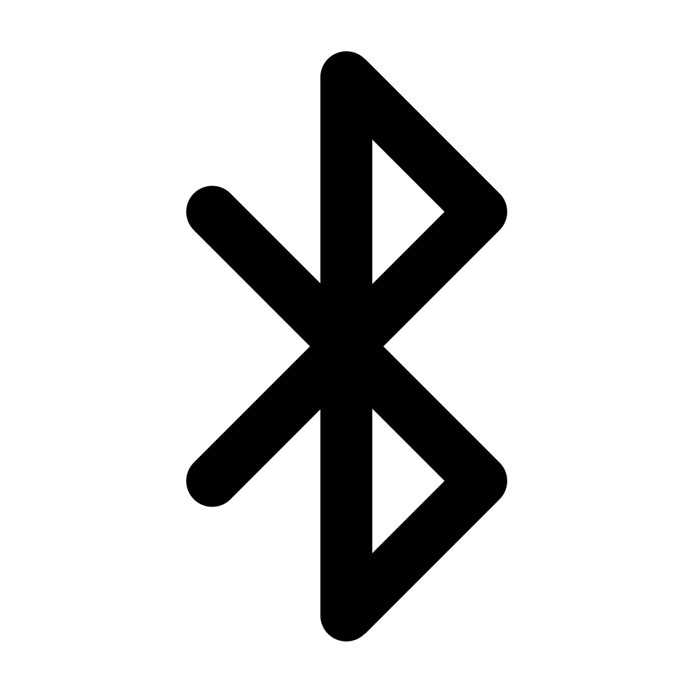

**Figure 1. Project Conceptual Image**

## ***Responsibility and Change Authority***

Urinrinoghene Omughelli, the team leader, will be responsible for keeping track of our progress and ensuring that we follow our milestones and validation plan. In case of any significant changes to the project, we will discuss them as a team before presenting those changes to our TA and Dr. Lusher.

|  |  |
| --- | --- |
| **Subsystem** | **Responsibility** |
| Android Application | Teammate 2 |
| Power Supply and Digital Signal Processor (Hardware) | Urinrin (Me) / Team Lead |
| Digital Signal Processor (Software) | Teammate 3 |
| MCU/Converters, PCB | Teammate 4 |

*Table 1: Responsibilities*

# **Applicable and Reference Documents**

## ***Applicable Documents***

The following documents, of the exact issue and revision shown, form a part of this specification to the extent specified herein:

|  |  |  |
| --- | --- | --- |
| **Document Number** | **Revision/Release Date** | **Document Title** |
| DOD-HDBK-791 | 3/17/1998 | Maintainability Design Techniques Metric |
| MIL-HDBK-217 | Revision F – 2/28/1995 | Reliability Prediction of Electronic Equipment |
| MIL-HDBK-263 | Revision B – 7/31/1994 | Electrostatic Discharge Control Handbook for Protection of Electrical and Electronic Parts, Assemblies and Equipment |
| MIL-C-39029D | Revision D - 05/98 | Contacts, Electrical Connector, General Specification |
| MIL-S-45743E | Revision E - 02/95 | Soldering, Manual Type, High Reliability Electrical & Electronic Equipment |

*Table 2: Applicable Documents*

## ***Reference Documents***

The following documents are reference documents utilized in the development of this specification. These documents do not form a part of this specification and are not controlled by their reference herein.

|  |  |
| --- | --- |
| **Document Title** | **Publisher** |
| Audio DSP with Analog Interface Datasheet | Texas Instruments |
| Audio DAC/ADC Datasheet | Analog Devices |
| ESP32 Datasheet | Espressif Systems |
| Lithium Ion Polymer Battery Datasheet | Tiny Circuits |

*Table 3: Reference Documents*

## ***Order of Precedence***

In the event of a conflict between the text of this specification and an applicable document cited herein, the text of this specification takes precedence without any exceptions.

All specifications, standards, exhibits, drawings or other documents that are invoked as “applicable” in this specification are incorporated as cited. All documents that are referred to within an applicable report are considered to be for guidance and information only, except ICDs that have their relevant documents considered to be incorporated as cited.

# **Requirements**

This section defines the minimum requirements that the development item(s) must meet. The requirements and constraints that apply to performance, design, interoperability, reliability, etc., of the system, are covered.

## ***System Definition***

**Android Application:**

This subsystem will be the user interface of the entire system. It will allow the user to connect to the audio Harmonizer via bluetooth. The user will be able to select between two modes of operation, automatic and manual. For automatic mode, the user will send inputs, such as the chord progression and beats per minute of the song to the harmonizer. For manual mode, the user will select the pitch they want the harmonies to match and send those via bluetooth.

**Power Supply:**

The power supply will consist of a low voltage rechargeable Lithium-ion battery which shall supply a maximum of 3.5 Watts (W) to the MCU, DSP, DAC/ADC. The voltage shall range from 4 Volts (V) when charged and 3.3 Volts (V) when discharged. The instantaneous power shall be estimated to be 0.33 Watts (W) and the battery capacity shall be 0.99 Ampere hours (Ah).

**MCU and Converters:**

The MCU will be the main communication between the DSP and user interface. Controlling the type of signal processing needed and certain parameters to ensure the overall fluidity of the harmonizer. The converters will be converting the analog to digital and vice versa directly to and from the DSP.

**DSP:**

The Digital Signal Processor will be loaded with algorithms to manipulate the digital audio signal into multiple harmonies. Using the input from the ADC and the MCU, the DSP will first check whether the user has requested manual harmony generation or automatic harmony generation. Then in real time using pitch shifting and a phase vocoder it will output the new frequencies as a digital signal to the DAC.

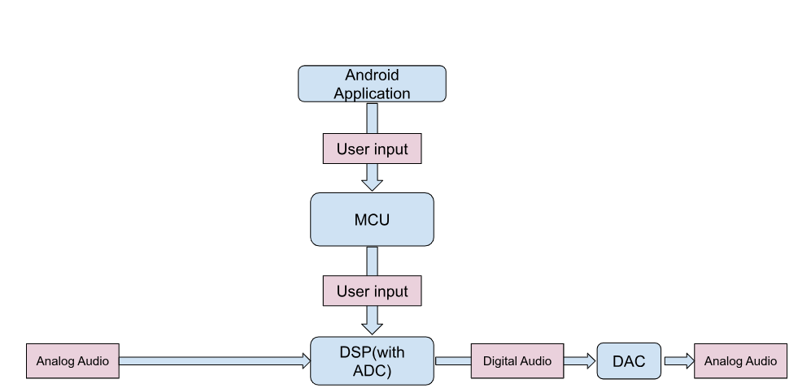

**Figure 2. Block Diagram of System**

## ***Characteristics***

### **Functional / Performance Requirements**

#### **Range of 2-4 Overlaid Harmonies**

The Audio Harmonizer System shall fall within the range of 2-4 overlaid harmonies to ensure user satisfaction. Any less than 2 harmonies would not be an effective harmonizer. In addition the harmonies have to follow music theory so the output is not discordant.

*Rationale: This is a core system performance requirement. The harmozier will have at least 2 harmonies to sound effective since the definition of harmonies is simultaneously occurring pitches. Any less than 2 harmonies makes our product function as a regular amplifier.*

#### **Bluetooth Requirements**

The Audio Harmonizer System will require the use of a bluetooth device to connect the Android application to the Audio Harmonizer. This will specifically connect the microcontroller unit and the android application to pass user input and mp3 recordings back and forth. The mp3 data sent between the MCU and Android App will be an optional feature to our system if there is time to implement it.

*Rationale: This is a core system performance requirement. The android application is a subsystem in itself, and it will need to connect to the audio generator to send inputs to the system.*

#### **Functional GUI**

The Audio Harmonizer System will have a functional GUI because this is the interface which allows the user to communicate with the system.

*Rationale: This is a core system performance requirement. It will be the bridge between the user and the phone. The GUI ensures that the user is able to pick notes and view recordings.*

### **Physical Characteristics**

#### **Mass & Size & Shape**

The mass of the Audio Harmonizer System shall be less than or equal to 3 kilograms. The size of the box itself should be at most 35cmx30cmx10cm. The Audio harmonizer will be in the shape of a box so it can lay on flat surfaces.

*Rationale: This is a requirement specified by our customer due to the requirement of portability. They will want to carry the system around with ease.*

#### **Input & Output**

The Audio Harmonizer shall have input and output with 3.5mm audio jack specifications.

*Rationale: This is a requirement because the user will need a way to connect their microphone and speaker to achieve the desired effects of the system.*

#### **Portable/Durable**

The Audio Harmonizer should be both portable and durable because the user will want to carry the box around if performing in multiple different locations. Also if there is a chance of rain, or the box is dropped, the system should be durable enough to withstand those conditions.

*Rationale: This is a requirement for our customer base since the system needs to be able to be used in real-world situations where unpredictable weather and circumstances can occur.*

#### **Bluetooth Range**

The range between the box and the phone should be about 20ft. Ideally, the user will have the phone right next to them to be able to use the app's features.

*Rationale: If the user is performing, they might not have their phone on them at all times, so they should be able to move around within reason without worrying about the connection cutting out.*

### **Electrical Characteristics**

#### **Inputs**

The input of our microphone should not lead to a failure in our system or cause the audio performance to diminish. The electrical input of the microphone will be via a 6.35mm audio jack.

*Rationale: Errors should be proactively avoided within the system.*

##### **Power Consumption**

The Audio Harmonizer shall be a low voltage/power system; thus, the maximum peak power consumption shall not exceed 3.5W given that the instantaneous currents and voltages shall not exceed 1 A and 3.3 V. Since the DSP, MCU and DAC/ADC circuits can be in use at any time, the instantaneous power for each circuitry is calculated and summed up based on the current and voltage ratings of integrated circuit (IC). The final power consumption shall be 0.33 W - 3.3 W. The battery capacitance shall be dependent on the current draw and the battery operating life which is estimated to be 0.99 Ah.

*Rationale: This is a requirement to prevent the overall system from overheating and causing damage while also ensuring proper power to the system.*

##### **Input Voltage Level**

The input voltage levels for the specified subsystems of the Audio Harmonizer System shall be as follows.

|  |  |
| --- | --- |
| Subsystem | Voltage |
| MCU | 3.3V |
| DSP | 3.3V |
| DAC/ADC | 3.3V |

*Rationale: Based on the Datasheets for the various parts mentioned above.*

#### **Battery Life**

The Audio Harmonizer System will require the use of a rechargeable battery that should last up to 2-3 hours per session.

*Rationale: The client will need to use this system for an entire performance which would be able to last for multiple hours.*

##### **Input Audio Sampling**

The input audio system shall sample at a rate of at most 20kHz in order to capture the full 20kHz-20 kHz range, this is implemented in our ADC/DAC and DSP.

*Rationale: Basics of Embedded Audio Processing*

#### **Outputs**

##### **Diagnostic Output**

Errors within the unit should be relayed to the application with a general error message that is displayed to the user on the Android Application.

*Rationale: Provides the ability to control errors within the system and alert the user of such circumstances.*

##### **Analog Output**

The analog will be outputted to an external audio speaker and will be in the correct format for the speaker to receive and output the audio with no errors and of high quality.

*Rationale: Provide correct output to the speaker so that the user can hear the resulting harmonies in real time.*

#### **Connectors**

Soldering will connect internal parts. Additionally, caps will be provided at external I/O ports to prevent contamination and malfunction. The audio harmonizer should follow the guidelines set by MIL-C-39029D.

*Rationale: External connectors need to be durable*

#### **Wiring**

The main unit will be developed and debugged in Altium to develop a PCB board. The audio harmonizer should follow the guidelines set by MIL-S-45743E.

*Rationale: Conform to rules of PCB design*

### **Environmental Requirements**

The Audio Harmonizer system shall be designed to withstand excess heat dissipation and generally hot environments.

*Rationale: This is a requirement since our system needs to be functional in real-world situations where heat and other factors have the potential to impact the product.*

#### **Thermal**

The audio harmonizer system shall withstand temperatures from 40F and 120F. There may be a heat sink used for dissipating excess heat generated during battery discharge.

*Rationale: This is a requirement so the system can be used in all performance climates.*

#### **External Contamination**

The black box shall be made of plastic. This will prevent contamination that occurs with metal such as rust.   
*.*

*Rationale: The audio harmonizer must be able to function in different locations of varying weather conditions.*

#### **Rain**

The circuitry will be housed inside a black box to prevent rain or liquid from sipping into the electrical components, which may get damaged by liquid.

*Rationale: This is a requirement since our system needs to be functional in real-world situations where heat and other factors have the potential to impact the product.*

#### **Humidity**

There may be holes on both sides of black box to aid air circulation. The device will be able to function in a range of 0% - 50% humidity.

*Rationale: Ensure that the main unit box is not over-exposed to humidity*

### **Failure Detection**

The Audio Harmonizer should have proper detection for electrical failures connected to the Harmony Generator and crashes that occur with the Android Application.

### **Support Requirements**

Customers are required to have an Android phone or device that can download the Audio Harmonizer Android Application. In addition, the Android device must have bluetooth functionality to connect with the Harmony Generator. The Harmony Generator will be battery powered with a rechargeable battery that we will provide. To use the Harmony Generator the customer must also have a microphone that connects to a 3.5mm audio cable, two 3.5mm audio cables, and a speaker that can connect the Harmony Generator via header pins.

# **Appendix A: Acronyms and Abbreviations**

mm Milli-meter

PCB Printed circuit board

F Fahrenheit

MCU Microcontroller Unit

kHz KiloHertz

W Watts

V Volts

AH Amp Hour

ADC Analog to digital converter

DAC Digital to analog converter

DSP Digital Signal Processor

# 

Audio Harmonizer

Urinrinoghene Lauretta Omughelli

**Interface Control Document**

REVISION – Final Report

December 5th 2021

**Change Record**

|  |  |  |  |  |
| --- | --- | --- | --- | --- |
| **Rev.** | **Date** | **Originator** | **Approvals** | **Description** |
| **-** | 09/29/2021 | Audio Harmonizer Team |  | Draft Release |
| **1** | 10/04/2021 | Audio Harmonizer Team |  | First Draft |

**Table of Contents**

[**Overview 35**](https://docs.google.com/document/d/1i8fVldsEZ9NZ0hQs8QLxOP_UVEufEfUD/edit#heading=h.4d34og8)

[**Reference and Definitions 35**](https://docs.google.com/document/d/1i8fVldsEZ9NZ0hQs8QLxOP_UVEufEfUD/edit#heading=h.2s8eyo1)

[2.1. References](https://docs.google.com/document/d/1i8fVldsEZ9NZ0hQs8QLxOP_UVEufEfUD/edit#heading=h.17dp8vu) 35

[2.2. Definitions](https://docs.google.com/document/d/1i8fVldsEZ9NZ0hQs8QLxOP_UVEufEfUD/edit#heading=h.3rdcrjn) 35

[**Physical Interface 35**](https://docs.google.com/document/d/1i8fVldsEZ9NZ0hQs8QLxOP_UVEufEfUD/edit#heading=h.lnxbz9)

[3.1. Weight](https://docs.google.com/document/d/1i8fVldsEZ9NZ0hQs8QLxOP_UVEufEfUD/edit#heading=h.35nkun2) 36

3.2. Dimensions 36

[**Thermal Interface 36**](https://docs.google.com/document/d/1i8fVldsEZ9NZ0hQs8QLxOP_UVEufEfUD/edit#heading=h.3j2qqm3)

**Electrical Interface 36**

[5.1. Primary Input Power 36](https://docs.google.com/document/d/1i8fVldsEZ9NZ0hQs8QLxOP_UVEufEfUD/edit#heading=h.4i7ojhp)

5.2. Microcontroller 36

[5.3. Audio Processing 37](https://docs.google.com/document/d/1i8fVldsEZ9NZ0hQs8QLxOP_UVEufEfUD/edit#heading=h.1ci93xb)

[5.4. Analog-Digital and Digital-Analog Converters 37](https://docs.google.com/document/d/1i8fVldsEZ9NZ0hQs8QLxOP_UVEufEfUD/edit#heading=h.2xcytpi)

[5.5. User Control Interface 37](https://docs.google.com/document/d/1i8fVldsEZ9NZ0hQs8QLxOP_UVEufEfUD/edit#heading=h.1ci93xb)

**Communications / Device Interface Protocols 37**

6[.1. Bluetooth Communication 37](https://docs.google.com/document/d/1i8fVldsEZ9NZ0hQs8QLxOP_UVEufEfUD/edit#heading=h.4i7ojhp)

6[.2. Android Phone GUI 37](https://docs.google.com/document/d/1i8fVldsEZ9NZ0hQs8QLxOP_UVEufEfUD/edit#heading=h.2xcytpi)

6[.3. MCU 37](https://docs.google.com/document/d/1i8fVldsEZ9NZ0hQs8QLxOP_UVEufEfUD/edit#heading=h.1ci93xb)

# **Overview**

The Interface Control Document will go over the Audio Harmonizer’s interfaces and connections that make up the full integrated functioning product. By separating our interfaces into four parts (physical, electrical, thermal, and communications), we will discuss the individual parts and pieces that make up our system and details that describe the specifications of our converters, signal processor, microcontroller, Android application, and the power source. The Audio Harmonizer will be made up of the Harmony Generator (which begins with an audio input from a microphone which is then sent through a converter, processed as a digital signal, and manipulated before being converted back into an analog audio signal) and the Android Application (a mobile application that the user interacts with and communicates via bluetooth to the Harmony Generator for signal processing). Due to the various parts that the Harmony Generator is composed of and the importance of the Android Application, the majority of the system focuses on the electrical and communication interfaces.

# **References and Definitions**

## ***References***

|  |  |  |
| --- | --- | --- |
| **Section Referenced** | **Link** | **Date Updated** |
| 3.2 Digital Signal Processor | <https://www.ti.com/product/MSP430FR5994> | N/A |
| 3.2 Digital and Analog Converters | <https://www.analog.com/media/en/technical-documentation/data-sheets/AD1836A.pdf> | N/A |
| 5.1 Lithium Ion Battery | [https://media.digikey.com/pdf/Data %20Sheets/TinyCircuits%20PDFs/ASR00036_Web.pdf](https://media.digikey.com/pdf/Data%20Sheets/TinyCircuits%20PDFs/ASR00036_Web.pdf) | N/A |
| 6.3 Microcontroller Unit | <https://docs.espressif.com/projects/esp-idf/en/latest/esp32/hw-reference/esp32/get-started-devkitc.html> | N/A |

## ***Definitions***

DSP Digital Signal Processor

MCU Microcontroller Unit

ADC Analog to Digital Converter

DAC Digital to Analog Converter

kHz KiloHertz

W Watts

A Ampere

V Volts

Ah Ampere hour

# **Physical Interface**

The physical makeup of the Audio Harmonizer system is a hardware circuitry that includes a DSP, MCU, and rechargeable lithium ion battery that will be placed into a black box. The black box will be made of thick board to keep the system as lightweight as possible.

The physical characteristic shall also include an external ready-made microphone and speaker. The microphone will be connected to the ADC on one side of the black box and the speaker/amplifier will be connected to the DAC on the other side of the black box.

## ***Weight***

In order for the Audio Harmonizer system to satisfy one of our system’s end goals, which is product portability, the weight shall be less than or equal to 3 kilograms. The microphone and speaker, since external and purchased separately, may be of any size deemed appropriate by the user.

## ***Dimensions***

The size of the black box was 35cmx30cmx10cm based on the size of the electrical wiring and circuit board that was placed into it.

### **Dimension of subsystems**

|  |  |
| --- | --- |
| Subsystem | Dimensions |
| DSP | The DSP shall be 12mm by 12mm in length and width |
| MCU | The length and width of the MCU shall be 55mm and 28mm, respectively |
| DAC/ADC | The DAC/ADC shall be 13.45 mm by 13.45 mm in length and width |
| Battery | The rechargeable lithium ion battery shall have a length, width, and height of 48mm, 6mm, and 30mm, respectively |

## ***Mounting Locations***

The electrical circuitry may be screwed onto the walls of the black box to prevent them from moving and getting destroyed. However, the black box does not need to be mounted at any location.

# **Thermal Interface**

The Audio Harmonizer will be a low power system so large power dissipation is currently not foreseen; however, there might still be some heat dissipation to get rid of during discharge of the lithium ion battery. A cold wall is not needed as there will be holes on both sides of the black box to allow for air circulation.

# **Electrical Interface**

## ***Primary Input Power***

Power will be provided by a 3.3 V rechargeable battery which will provide a minimum of 2 hour battery life and a battery capacity of 850 mAh. The power supply is used for the MCU, DSP, and ADC/DACs.

## ***Microcontroller***

Will use an ESP32 that will control the type of signal processing needed. The microcontroller receives this data from the user interface(android application) via bluetooth. The microcontroller will be powered with 3.3 V power supply.

## ***Audio Processing***

Will use a specified DSP to process the digital signals to create 2-4 harmonies with an algorithm that will take into account chord progression, arrap tuples, and tempo. This digital signal then is sent to the DAC. The DSP will be powered by a 3.3 V power supply.

## ***Analog-Digital and Digital-Analog Converters***

Will use ADC/DAC with 24 bit and 20 kHz input sample rate capabilities to be powered by 3.3 volts.

## ***User Control Interface***

The user interface will be handled by an external device either smartphone or emulator through android studio.

# **Communications / Device Interface Protocols**

## ***Bluetooth Communication***

There will be a bluetooth connection between the harmonizer and the android application. These connections will be used for the android application to send inputs such as chord progression and beats per minute to the audio generator. It will also be used for the black box to send recordings of the audio back to the android application.

## ***Android Phone GUI***

This is used for the user to communicate with the audio harmonizer system. The GUI will allow the user to interact with the system in a way that is clear and concise. There will be an initial setup page where the user connects to the system via bluetooth, then they will be redirected to the home page where they can select between the two modes of operation.

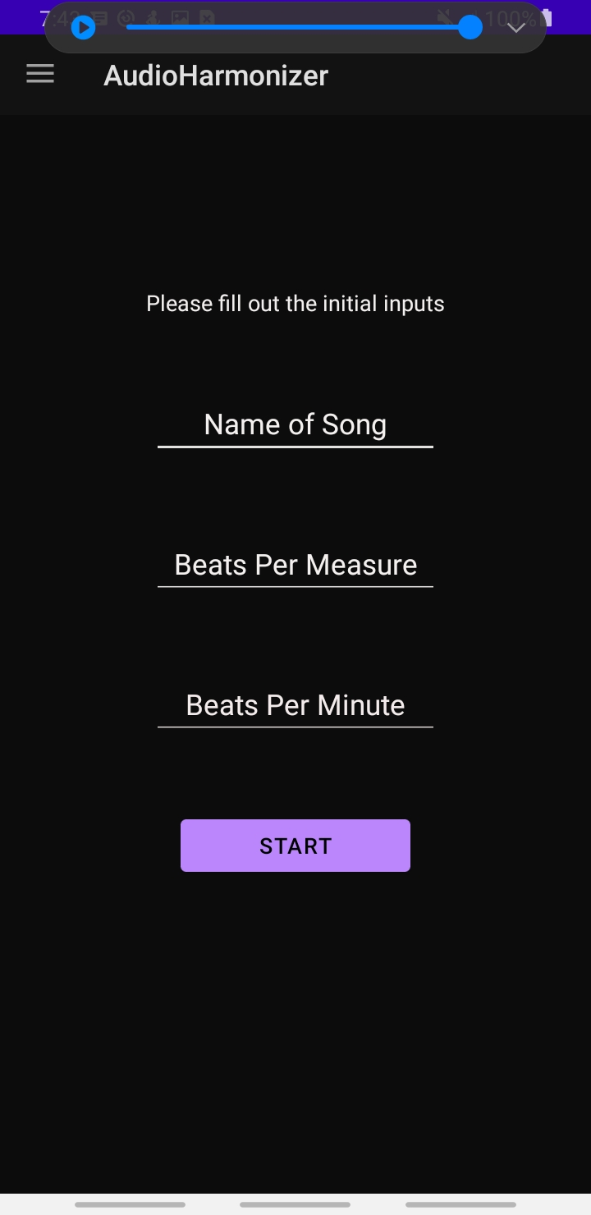

*Output Snippet 6.2.1: Initial Inputs*

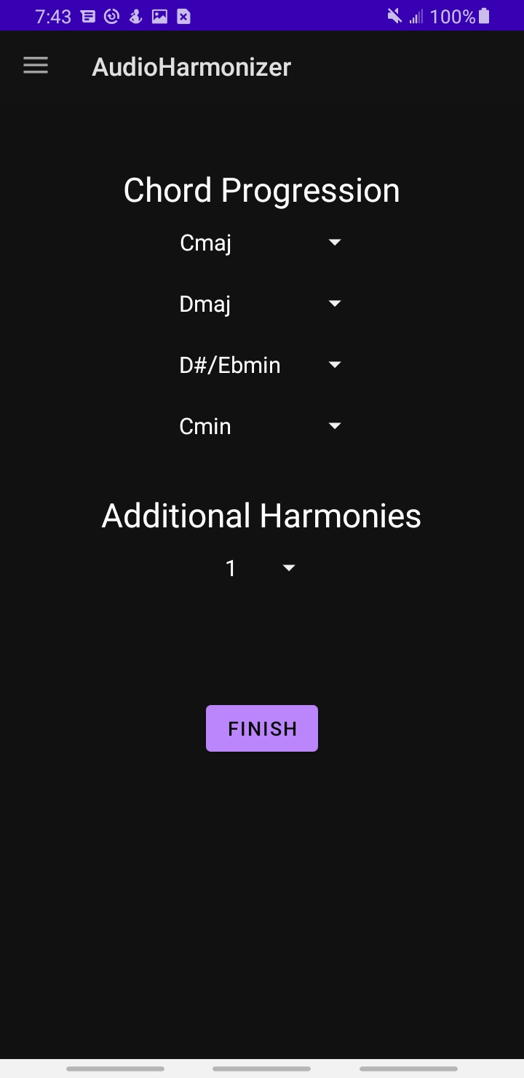

*Output Snippet 6.2.2: Automatic*

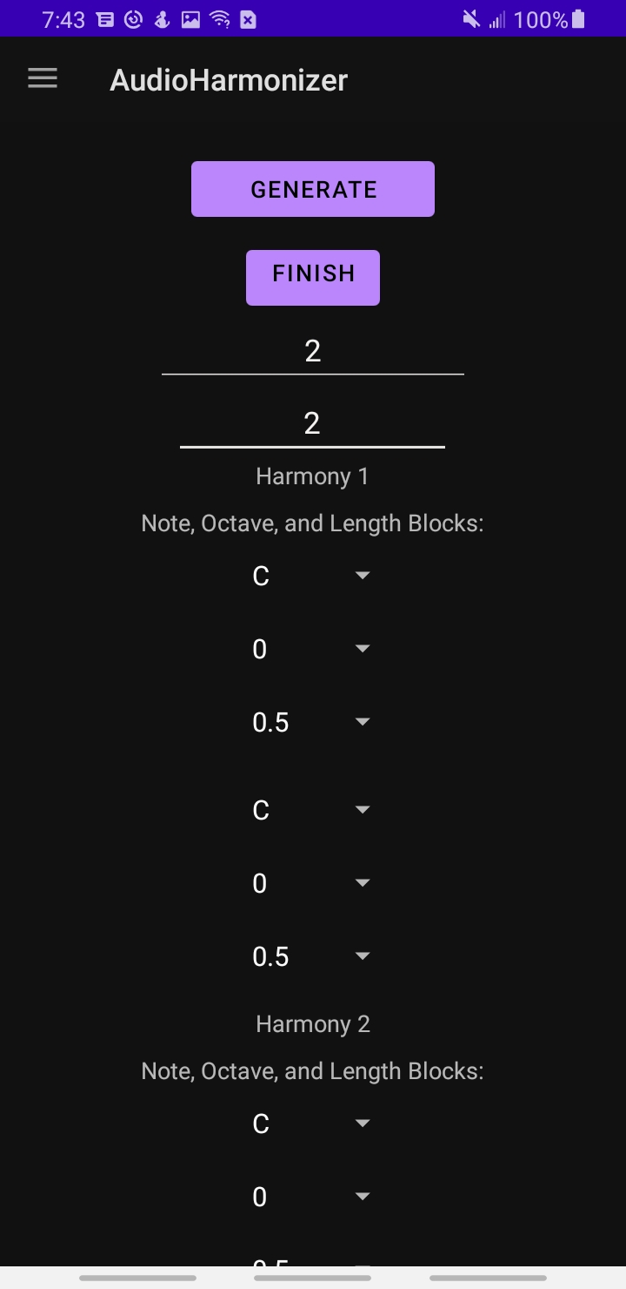

*Output Snippet 6.2.3: Manual*

## ***MCU***

The Microcontroller Unit connects all of the subsystems. It will use bluetooth to communicate with the Android Application. It will also communicate with the Digital Signal Processor to process an input digital signal from the ADC, as well as receive the final digital signal from the DSP.

Audio Harmonizer

Urinrinoghene Lauretta Omughelli

# 

# **Subsystems Report**

REVISION – Final Report

December 5th, 2021

Table of Contents

**Subsystems Report** **49**

**Introduction** **52** 69

**Subsystem 4: Power Supply**81

Introduction 82

Operation 83

Battery Charging Mode 85

Battery Not-charging/Discharging Mode 86

Battery Voltage Monitoring and I2C Communication Mode 86

Output Voltage DC-DC Conversion Mode 87

Validation 88

Battery Charging Results 88

Battery Not-charging/Discharging Results 90

Battery Voltage Monitoring and I2C Communication Results 91

Output Voltage DC-DC Conversion Mode Results 95

Conclusion**Subsystem 3: Android Application** **69**

Introduction 69

Operation 69

Bluetooth Page 69

Home Page 70

Initial Inputs Page 71

Modes of Operation Page 72

Automatic Page 72

Manual Page 73

Start Singing Page 74

Validation 75

Navigation Bar 75

Manual Page 75

Application only connects to one device 77

Bluetooth Disconnection 78

Sending Data - User Inputs 79

Receiving Data - Battery Level 81

Conclusion 82

100

# Introduction

Over the course of the two semesters, each member of our team made progress on their individual subsystems and then on integrating said systems. In this document, I explain the process I took to reach the goals for my individual system (Power Supply) as well as explain the validation I followed to ensure it worked

# 1. Subsystem 4: Power Supply

## Introduction

The power supply’s circuitry was designed to supply 3.3 VDC to the MCU and DSP. It is made up of a rechargeable lithium ion battery, battery charger IC (BQ24232HRGTR), fuel gauge IC (BQ27411DRZT-G1C), and buck boost converter (TPS630250RNCT) to step up or step down the output voltage to its required level. The battery charger IC receives 5 VDC supply from a power adapter rated at 5 VDC. The battery supplies power directly to the MCU and DSP through the converter and the charger IC, once powered up, is able to charge the battery until it gets to a fully charged voltage of 4.2 VDC. While charging the battery, the charger IC is also able to independently power the MCU and DSP through the converter. This is depicted in Figure 5.1.1 below.

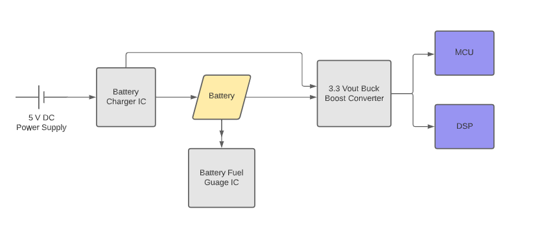

*Flow Diagram 5.1.1: Power Supply Circuit Diagram*

## Operation

The circuitry of the power supply has two main modes of operation which include charging and not-charging/discharging. Other modes of operation include the battery voltage monitoring/I2C Communication, and output voltage DC-DC conversion. These modes are explained in the following subsections. In addition, the schematic and PCB for the power supply are shown in Figures 5.2.1 and 5.2.2, respectively.

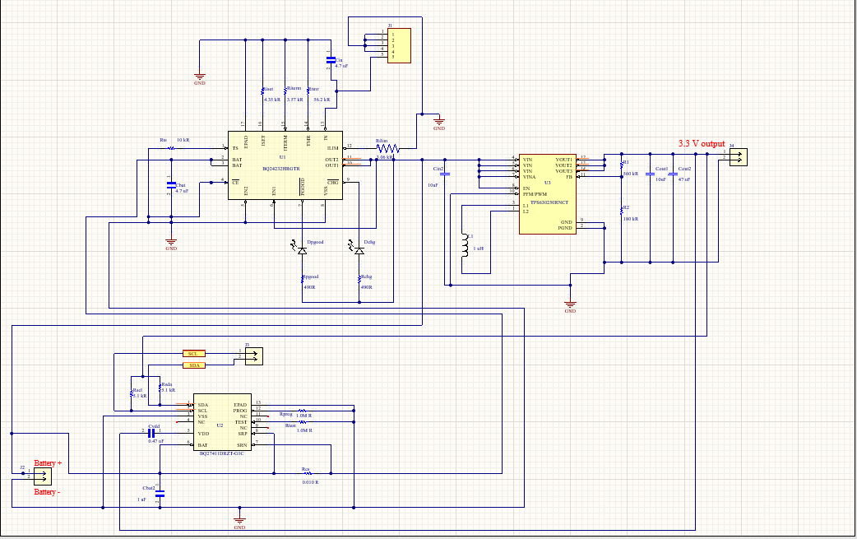

*Circuit Design 5.2.1: Power Supply Schematic*

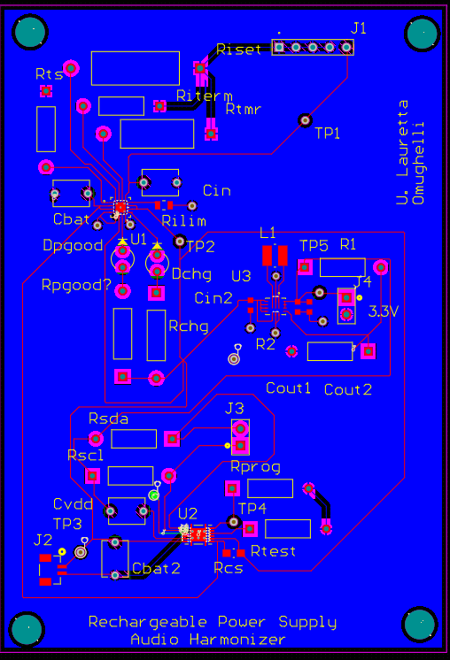

*Circuit Design 5.2.2: Power Supply PCB*

### Battery Charging Mode

This mode's operation is depicted in the Figure 5.2.1.1 below. When the battery is connected and charging, the main power supply comes from the battery while the battery charger takes on the role of charging the battery. Once the battery is connected and charging, we are able to see an indication of this through the Dchg LED. This LED will have a low impedance or light up to indicate that the battery is being charged.

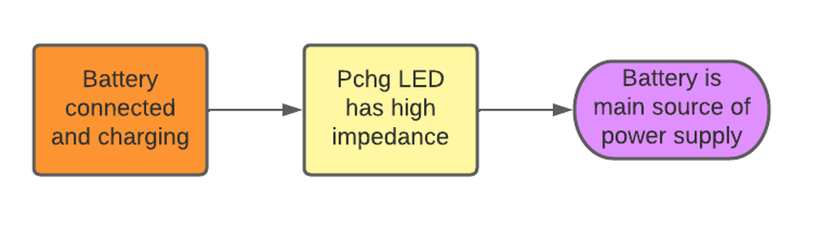

*Flow Diagram 5.2.1.1: Battery Charging Mode*

### Battery Not-charging/Discharging Mode

As depicted in the figure below, in this mode, the charger IC takes on the role of being the main power supply if the battery is disconnected or not charging due to a faulty battery being detected. The Dchg LED also has a high impedance in which the LED is off to indicate that the battery is not an active component in the power supply’s circuitry.

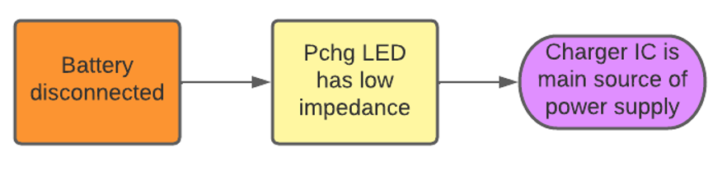

*Flow Diagram 5.2.2.1: Battery Not-Charging Mode*

### Battery Voltage Monitoring and I2C Communication Mode

To monitor the battery’s voltage, a fuel gauge IC (part number: BQ27411DRZT-G1C) was connected to the battery on the board. This chip is able to monitor the battery’s voltage, current, and state of charge through the current sensing resistor which is placed in series with the positive terminal of the battery and the SRN pin of the fuel gauge IC. It was also critical that this chip was connected correctly for it to accurately perform its function. To do this, two pull up resistors were placed across the I2C pins (known as the SDA and SCL pins) and to the output voltage of the converter. The battery’s voltage, current, and state of charge are then communicated to the MCU via I2C communication, which is programmed through the SDA and SCL pins. These values are then transmitted from the MCU via bluetooth to the Android Application, where the battery levels can be monitored. Results of testing this operation will be presented in the validation section for this sub system.

### Output Voltage DC-DC Conversion Mode

The battery charger outputs 4.5 VDC while the battery outputs 3.0-4.2 VDC. Since the MCU and DSP require 3.3 VDC, a DC-DC buck-boost converter (part number: TPS630250RNCT) was needed to step up or step down this voltage to the required voltage level, regardless of what voltage level was supplied to the converter. The results of the test for this operation are shown and discussed in the validation section.

Initially, a TPS630250RNCT converter was used in the original design of the power supply circuit board. However, the converter chip obtained a short inside of it and all efforts made to resolve this issue proved to not completely work. Therefore after discussing with our sponsor, we decided a linear voltage regulator (part number: TC2117), as seen in the circuit board in Figure 5.2.4.1, was best to be used as all other buck boost converter ICs were out of stock.

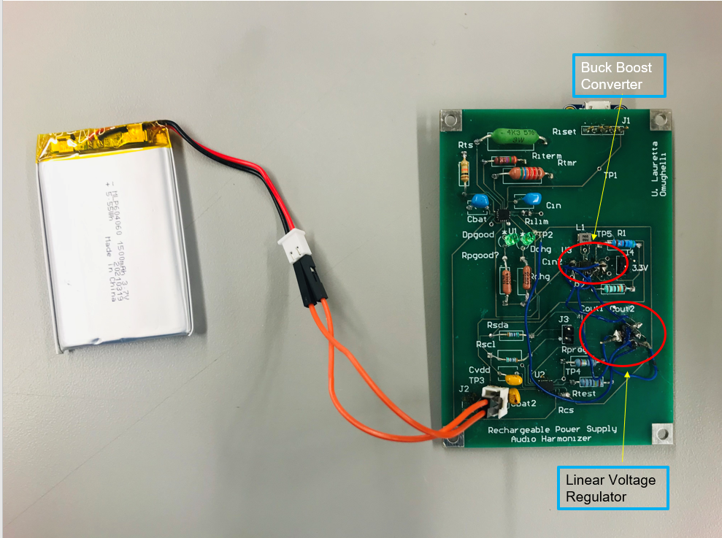

*Figure 5.2.4.1:Final Physical Circuit Board with Linear Voltage Regulator*

## Validation

The validations for the power supply are discussed in the following subsections below.

Link to power supply (battery and output voltage) demo. <https://youtube.com/shorts/1JbxCoWlsLc?feature=share>

### Battery Charging Results

To validate this operation, the battery was connected in the circuit and the test point for the battery’s output voltage was probed using a multimeter to verify an expected voltage that is greater than 3.7 VDC since it was being charged. As seen in figure 5.3.1.1. We got an expected voltage of 3.9 VDC which also confirms that the battery was the main source of power supply in this case.

The Dchg LED is then observed and as stated earlier, we expected the LED to light up to signify that the battery is connected in the circuit, charging, and is now the main source of power supply. The result for the LED was also accurate as there was low impedance which resulted in the LED being lit up as seen in Figure 5.3.1.2 below.

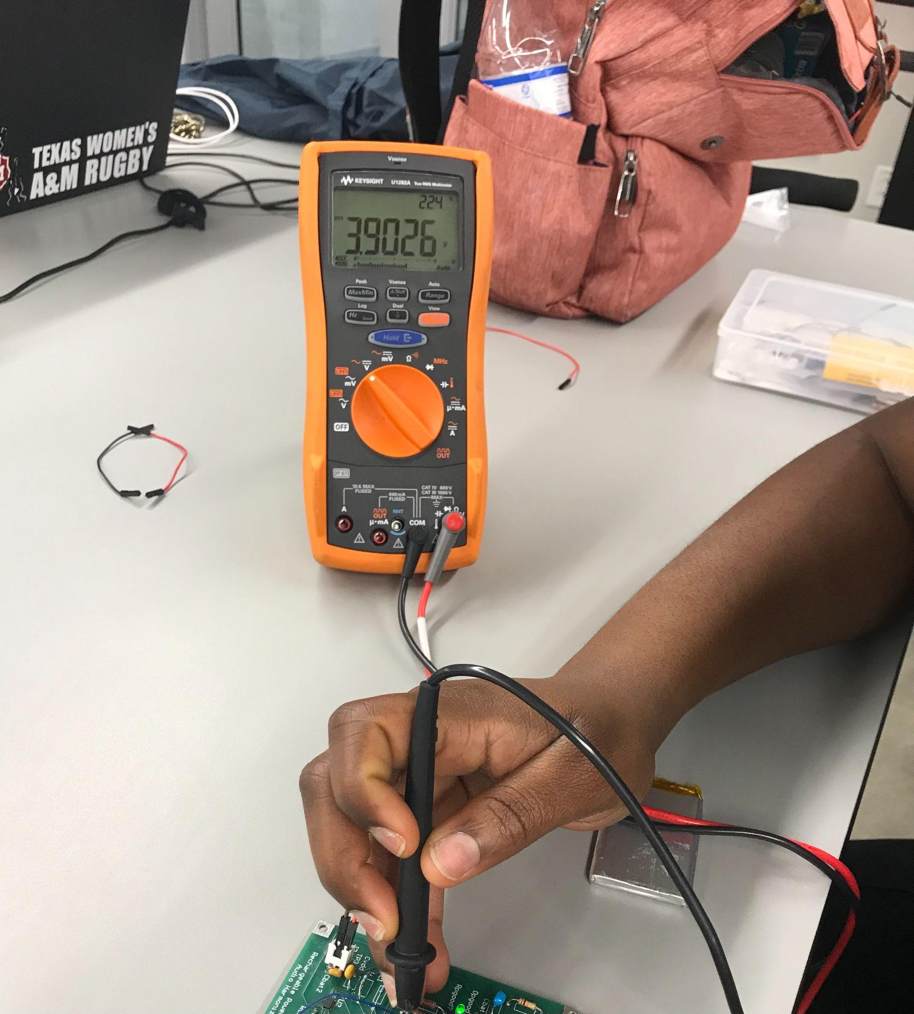

*Probed testpoint 5.3.1.1: Battery Output Voltage When Battery Is COnnected and Charging*

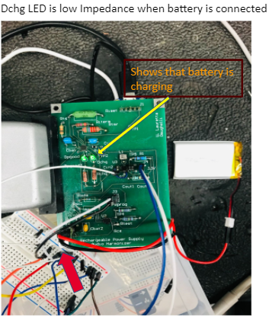

*LED 5.3.1.2: Low Impedance indicates battery charging*

In addition, since the power supply circuit was designed in a way that it could get fully charged in 60-90 minutes with a battery lifetime of 4 hours, it was important to monitor the battery voltage with respect to time and to ensure that a constant current is observed when the battery is charged. The data for this test was collected every ten minutes and the graph below validates the constant current of 5.7 mA when the battery is charging, in addition to a charge time of approx. 1.5 hours at a battery capacity of 1500 mAh.

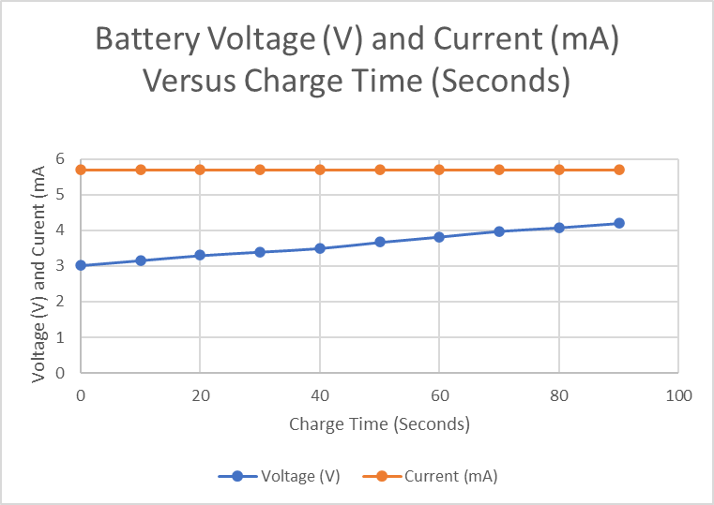

*Graph 5.3.1.3: Battery charging at constant current*

### Battery Not-charging/Discharging Results

The battery was then disconnected from the circuit and the results validated that the battery was no longer charging as the Dchg LED was high impedance resulting in limited current flowing into the LED; hence the LED not being lit up. For extra validation, a Pgood LED was used to show that the battery charger IC is powered on and is receiving a valid input source. This is depicted in Figure 5.3.2.1 below.

Furthermore, the main power supply test point was probed and a multimeter was used to confirm that the battery charger was now the main source of power supply. As seen in Figure 5.3.2.2 below, the main power supply voltage reads an expected voltage 4.53 VDC (as opposed to the previous voltage of 3.9 VDC when the battery was connected in the circuit making it the main source of power supply) and since the output voltage of the battery charger is expected to be 4.5 VDC, this then validates that the battery charger IC is the main source of power supply when battery is disconnected.

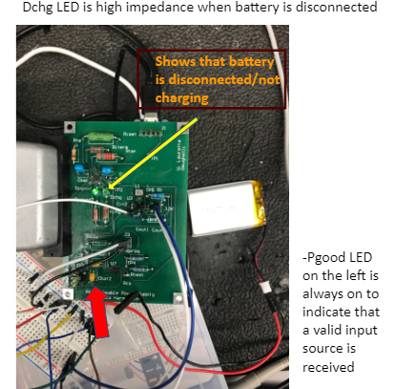

*LED 5.3.2.1: High Impedance indicates battery disconnected*

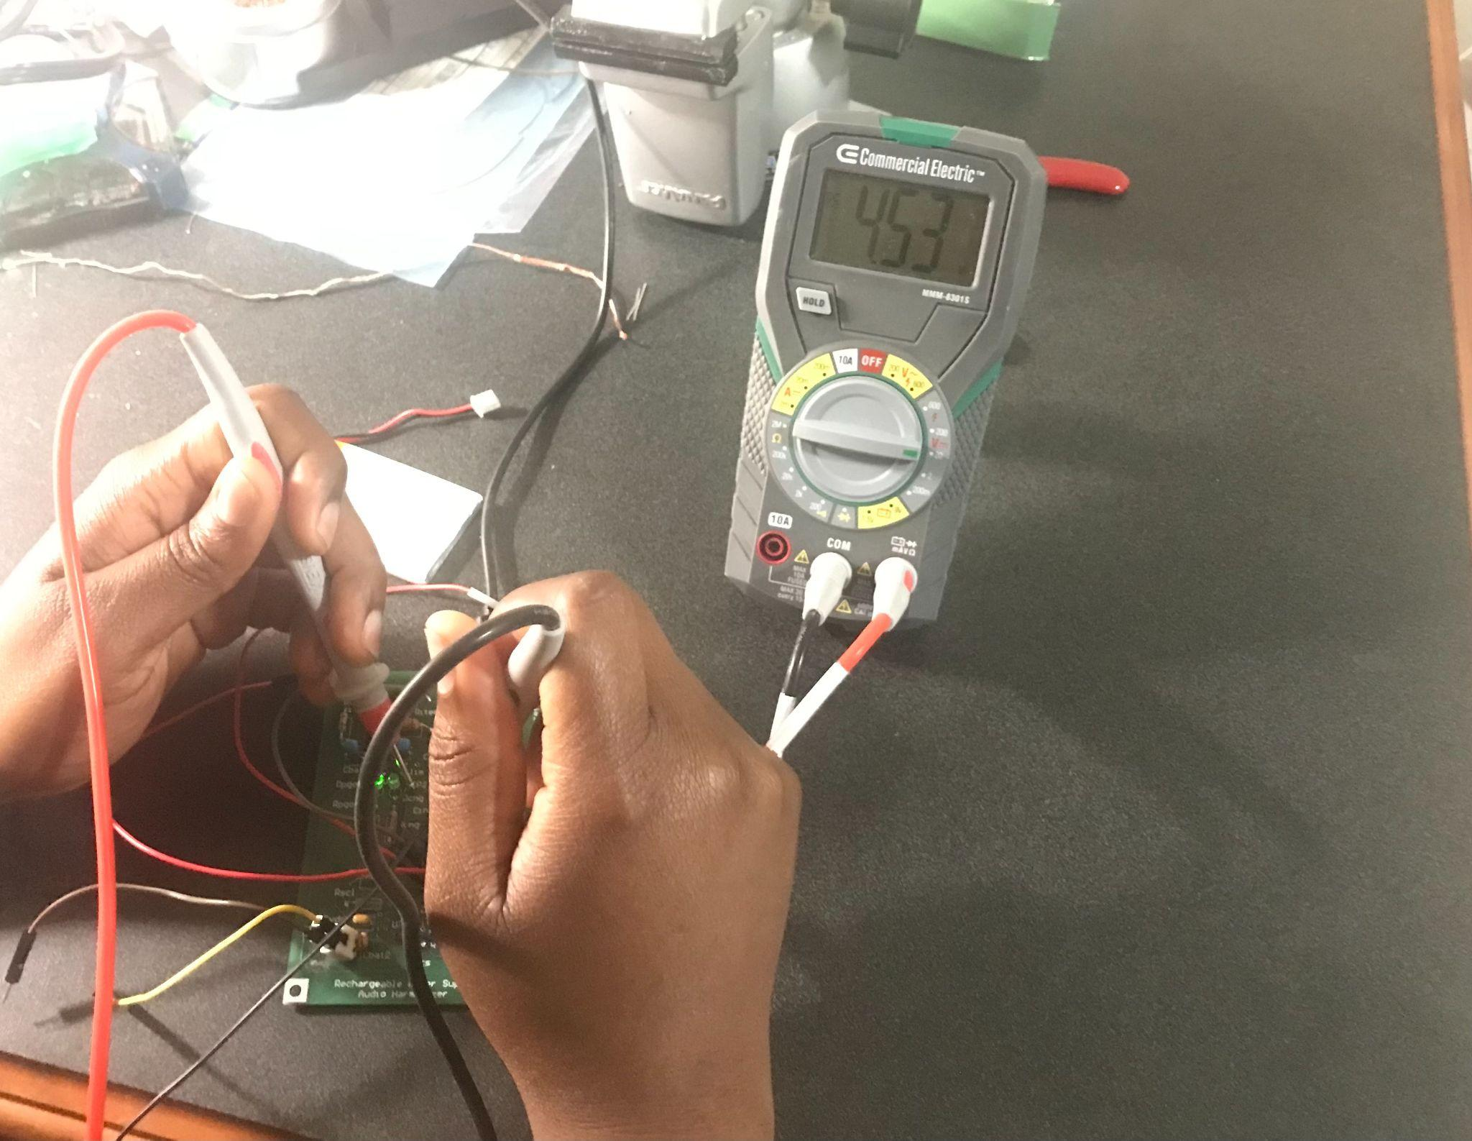

*Probed Testpoint 5.3.2.2: battery Charger IC Voltage When Battery Is Disconnected*

Furthermore, the design requirement of the power supply was a lifetime of 4 hours before the battery becomes completely discharged which would make the battery charge IC the main source of the power supply on the circuit.

To validate this battery lifetime, the battery was fully charged to 4.2 VDC, left to discharge, and the data was taken every 20 minutes. The graph below validates that the battery does stay running on its own for 4 hours before it is drained and required to be recharged.

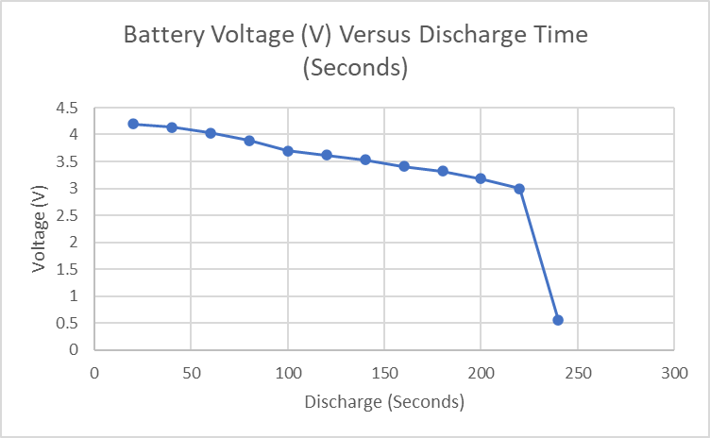

*Graph 5.3.2.3: Battery discharging over time period of 4 hours*

### Battery Voltage Monitoring and I2C Communication Results

After the SDA and SCL pins were connected properly using pull up resistors, the SDA and SCL pins were then connected to an ESP32 (MCU) for verification of I2C communication through which the battery’s voltage, current, and state of charge were communicated.

In order to read these values, I2C programming was employed. An arduino library that contained some command protocols for the fuel gauge was retrieved and used for the programming. Since the code did not accurately calculate the state of charge, the state of charge was calculated based on the battery’s voltage and the code was modified based on these calculations. A snippet of the arduino code is shown in Figure 5.3.3.1.

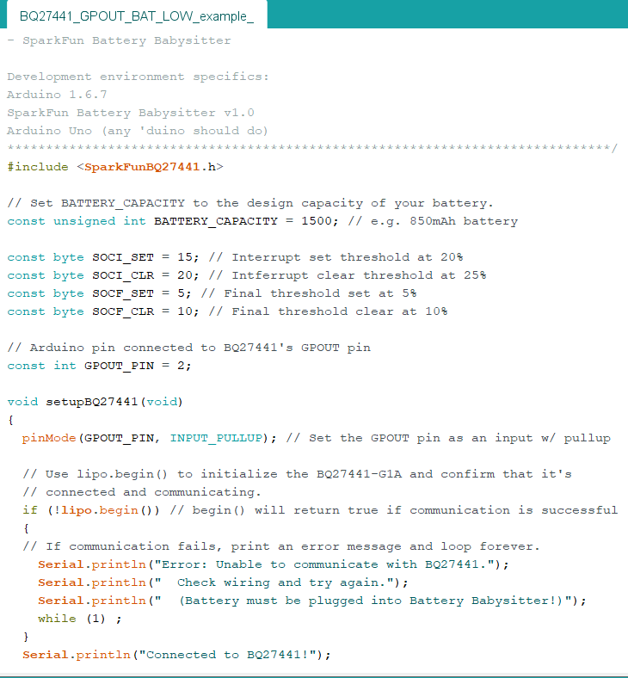

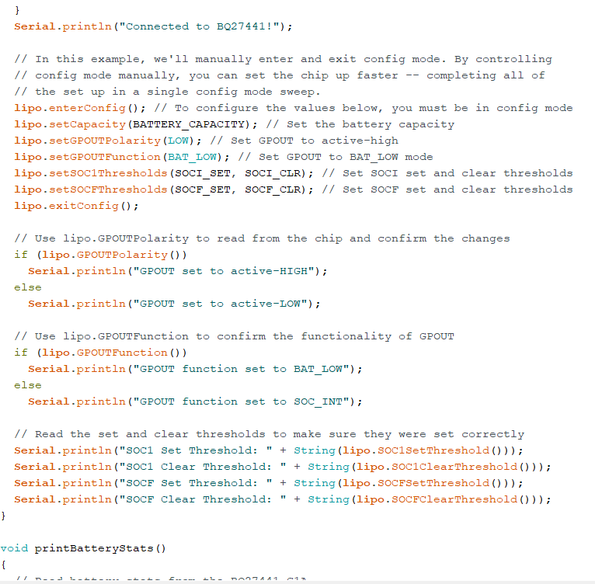

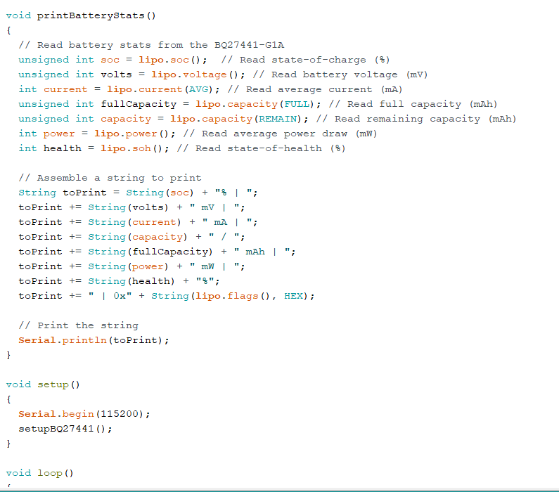

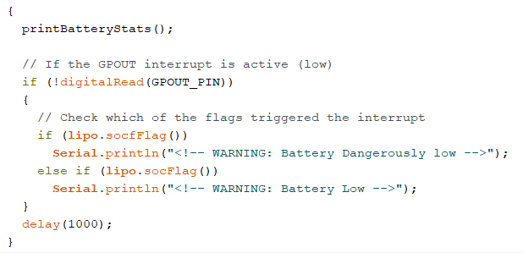

*Battery Information Reading Code Snippet 5.3.3.2: Fuel Gauge I2C Programming Codes*

Validation of this code which shows the battery voltage is seen in the snippet of the console window shown in Figure 5.3.3.2

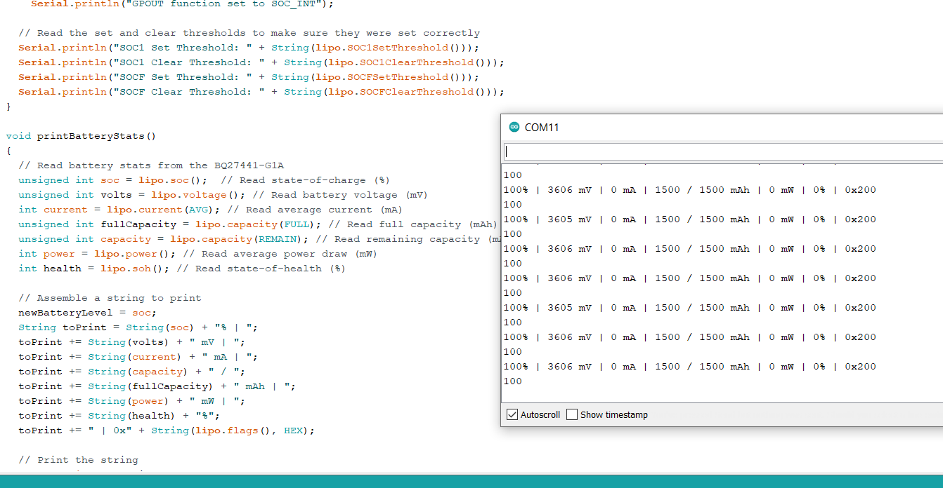

*Fuel Gauge Console Snippet 5.3.3.2: Battery Voltage Level Validation on Arduino Console*

### Output Voltage DC-DC Conversion Mode Results

A DC-DC buck boost converter had been chosen to change the 4.5 VDC from the battery charger and the 3.0-4.2 VDC from the battery to a constant 3.3 VDC. Initially, the chip worked fine as it supplied an output voltage of 3.25-3.36 VDC as shown in Figure 5.3.4.1 below. This value had a percentage error of 1.52 % compared to the expected 3.3 VDC, but since this was below the percentage error limit of 5% VDC, this value was acceptable.

However, the chip we got had a short inside it and due to buck boost converter chips being out of stock. A linear regulator was used to replace it. However, efforts were made to validate the converter’s fault and are documented below.

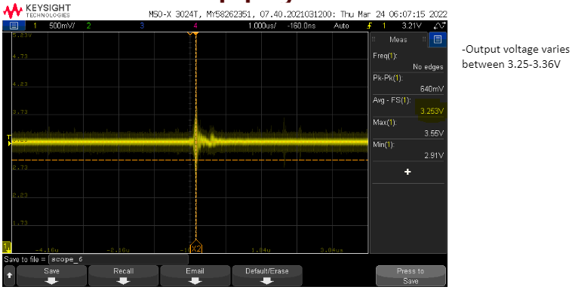

*Oscilloscope Snippet 5.3.4.1: Output Voltage With Buck Boost Converter*

I. Power Save Mode Validation and Resolution

The converter device was designed to work in Pulse Width Modulation (PWM) mode at load currents of approximately 350 mA or greater. This enables the device to automatically switch over to power save mode in order to extend the batter’s lifetime by minimizing power consumption. In power save mode, the device starts at a low output voltage of 2.6 VDC and gradually increases to the expected voltage of 3.3 VDC in a total time period of 1 hour as shown in the graph in Figure 5.3.4.2.

1. Disabling Power Save Mode

When the buck boost converter had this issue of getting to 3.3 VDC as seen as as the device is powered on, it was noticed that the PWM pin of the device was connected to ground as seen in the zoomed in portion of the schematic in figure 5.3.4.3. To correct this on the physical circuit cord, an exacto knife was used to cut the trace connecting PWM to ground. Instead, this pin was connected to the VIN of the chip which helps to disable power save mode.

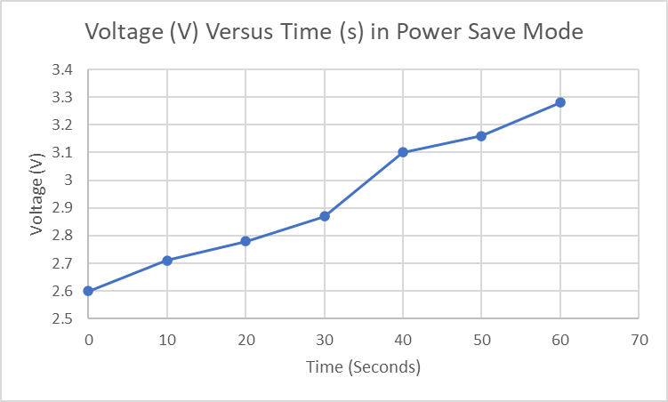

*Power Save Mode Voltage Delay Graph 5.3.4.2: Voltage Versus Time*

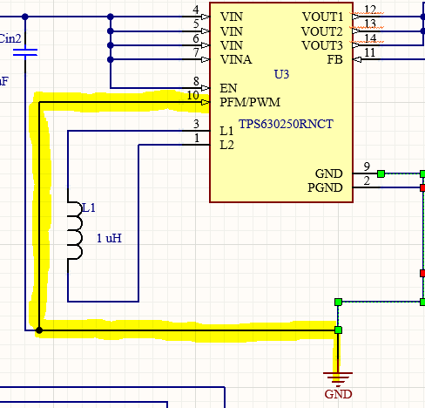

*Schematic 5.3.4.3: Converter PWM Connected to GND to enable Power Save mode*

1. Feedback Voltage/Resistor Recalculation

Connecting PWM pin to VIN did not completely resolve the problem, therefore, the resistors feedback resistors connected to the converter were recalculated and changed out on the board to ensure that the feedback voltage was exactly at 0.8 VDC as specified in the device’s datasheet. However, since the calculated resistor value was already being used, the feedback voltage on the converter device of the physical board was measured and was found to be 0.74 which was beneath the threshold value. Therefore, the higher values of feedback resistor values were used, such as 190 K ohms, 200 K ohms, 250 K ohms. The equation for these calculations is shown in Equation 5.3.4.1 below.



*Equation 5.3.4.2: Feedback Resistance*

Where,

R1 = Feedback Resistor

R2 = Output Resistor

Vout = Expected Output Voltage

VFB = Feedback Voltage

1. Resoldering

Since recalculation and changing of the resistors in resolution/validation point b above did not resolve the power save mode issue, it was critical to ensure that the the wire used to correct and connect PWM pin to VIN were stable and had a larger surface area of power as this was a power route. Therefore, the component parts, including the converter chip, were resoldered and connectivity across the components was checked with the use of a multimeter to ensure strong connection between pins and components.

All efforts were made to fix the output voltage delay issue but none of them completely resolved this issue, it was determined by myself and our sponsor that the chip had an internal shortage and the final resolution recommendation together with its validation is seen in the following sub-section.

1. Linear Voltage Regulator

Since the buck boost converter was faulty and all other buck boost converter chips were out of stock, a linear voltage regulator as seen in Figure 5.2.4.1 was used to solve the voltage delay and power save mode issue. The output voltage was tested and worked very well as there power save mode or output voltage delay when the circuit is power on. The validation results from the multimeter and oscilloscope showed a constant output voltage of 3.285 V as soon as the circuit was powered on. This validation is shown in the figure below.

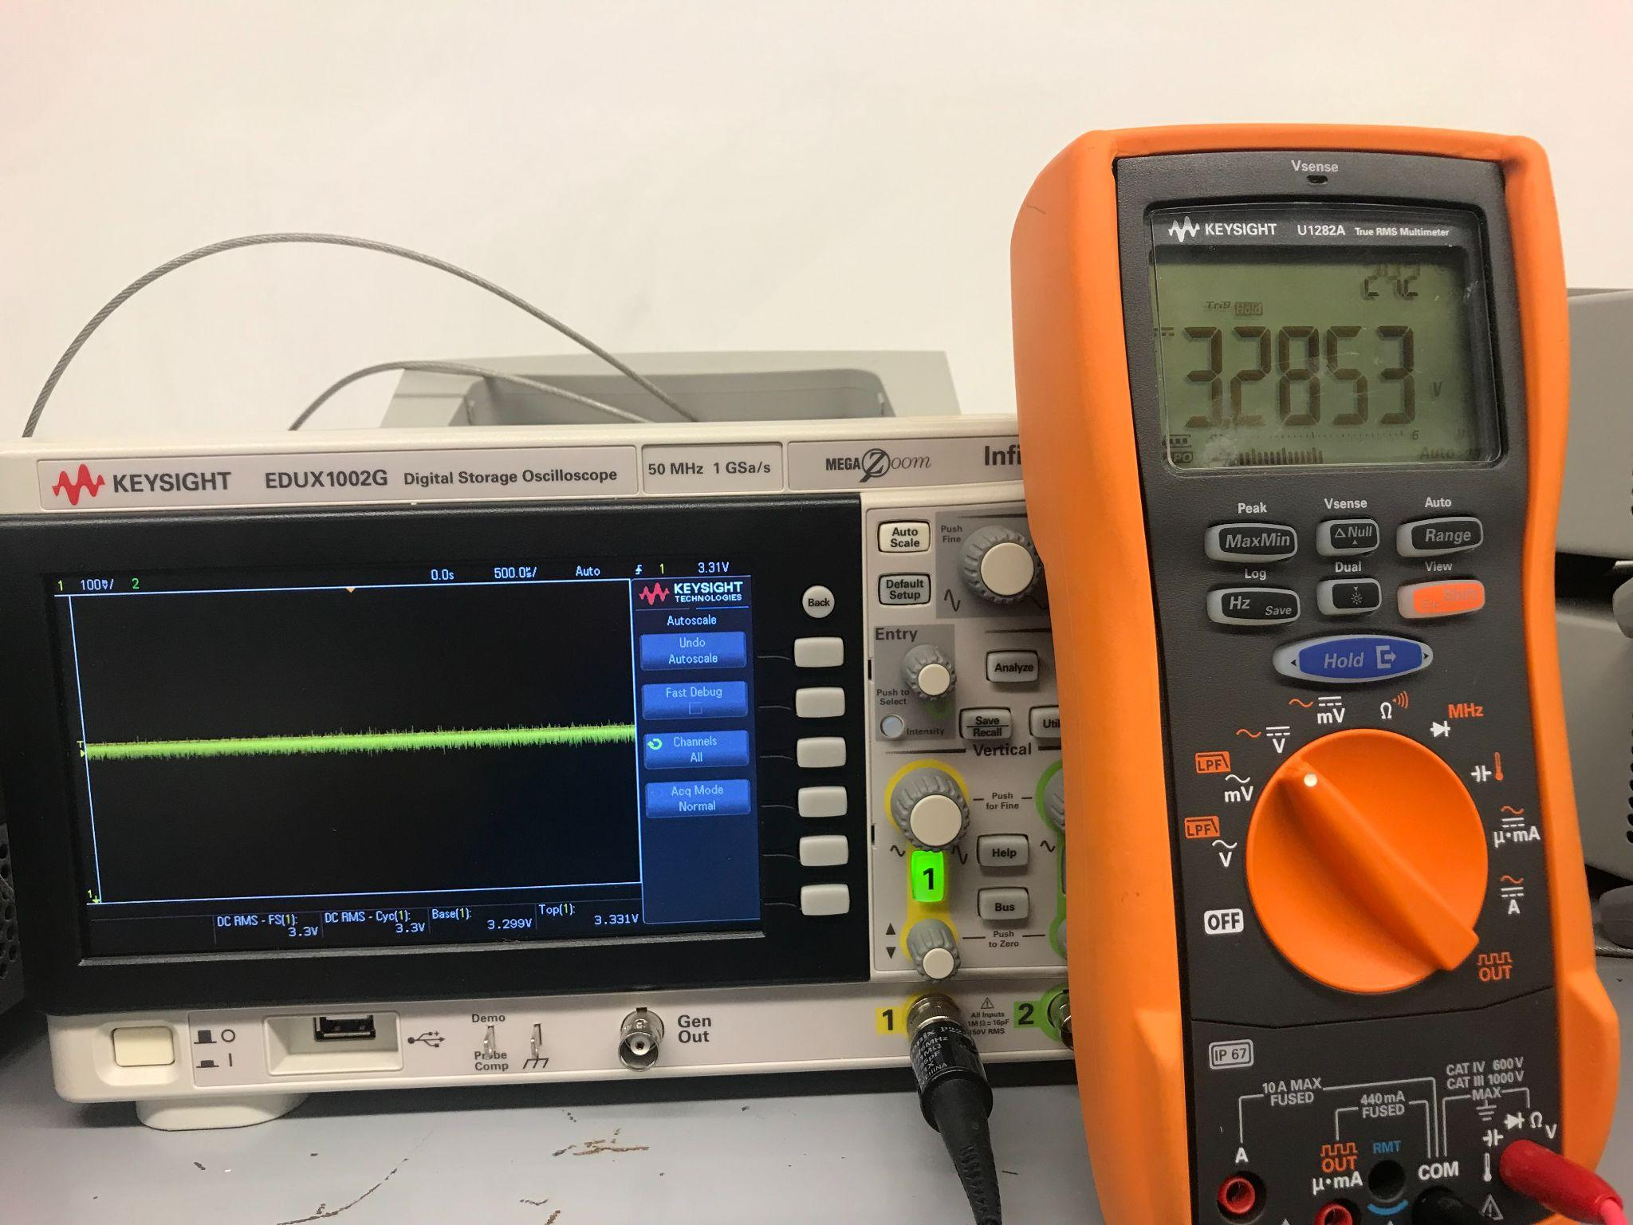

*Oscilloscope and Mulimeter 5.3.4.4: Output Voltage Validation with Linear Regulator*

Although this multimeter shows an output voltage of 3.2853 VDC which is very close to the oscilloscope’s output voltage of 3.3 VDC, we can confirm that both values are expected and correct but the oscilloscope’s value is more accurate due to precision settings on the multimeter. In addition, we see very little to no noise on the output voltage of the voltage regulator. This showed that the use of the linear voltage regulator did a good job of converting the 4.5 VDC and 3.0-4.2 VDC input voltages to the constant expected DC voltage of 3.3 V.

## Conclusion

The issues faced in designing and getting the power supply output to a steady 3.3 VDC were effectively navigated through brainstorming, debugging, validation of hardware and PCB, and analysis of validation results. In the end, the power supply reached its goal of charging within 1.5 hours and lasting for 4 hours before the voltage was completely discharged or drained. The battery charger IC, fuel gauge IC, and linear voltage regulator worked as expected making this subsystem a successful portion of the project.

# Subsystem: Android Application (In relation to Power Supply)

## Introduction

The Android Application was designed to be the user interface of the Audio Harmonizer. This subsystem allows the user to select inputs for both manual and automatic modes of operation. The Android app communicates with the Audio Harmonizer via bluetooth to send user inputs and receive battery percentages from the MCU.

## Operation

This application has two main modes of operation which are automatic and manual. There are eight different pages in the application that take you through the process of creating additional harmonies

### Bluetooth Page

The bluetooth page is where the user establishes a connection between the device and the Audio Harmonizer. This page has a button that allows the user to turn bluetooth on and off, a button that makes the device discoverable to other devices. It also has a button that discovers other devices, as well as a button that starts a connection between two devices after they have been paired.

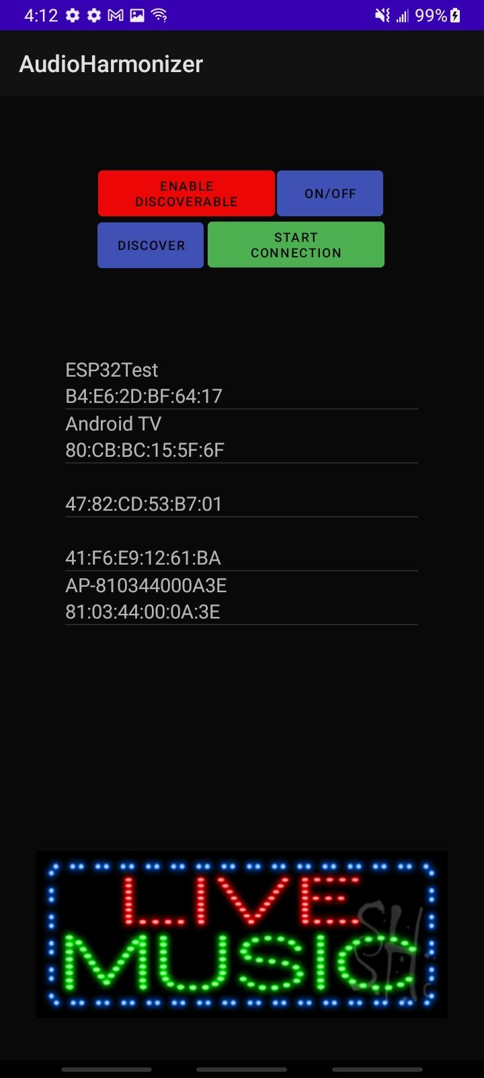

*Output Snippet 4.2.1.1: Bluetooth Page*

### Home Page

The home page contains the logo for the application as well as a button that links to the initial inputs page.

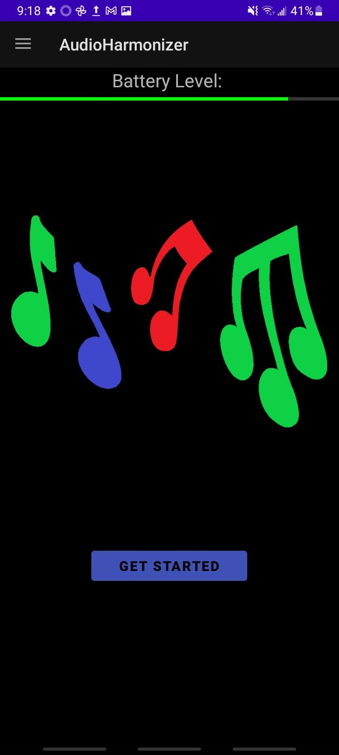

*Output Snippet 4.2.1.1: Home Page*

### Initial Inputs Page

This page contains three text fields and all of those inputs are sent to the audio harmonizer regardless of the mode of operation selected. It also has a start button which links to the modes of operations page.

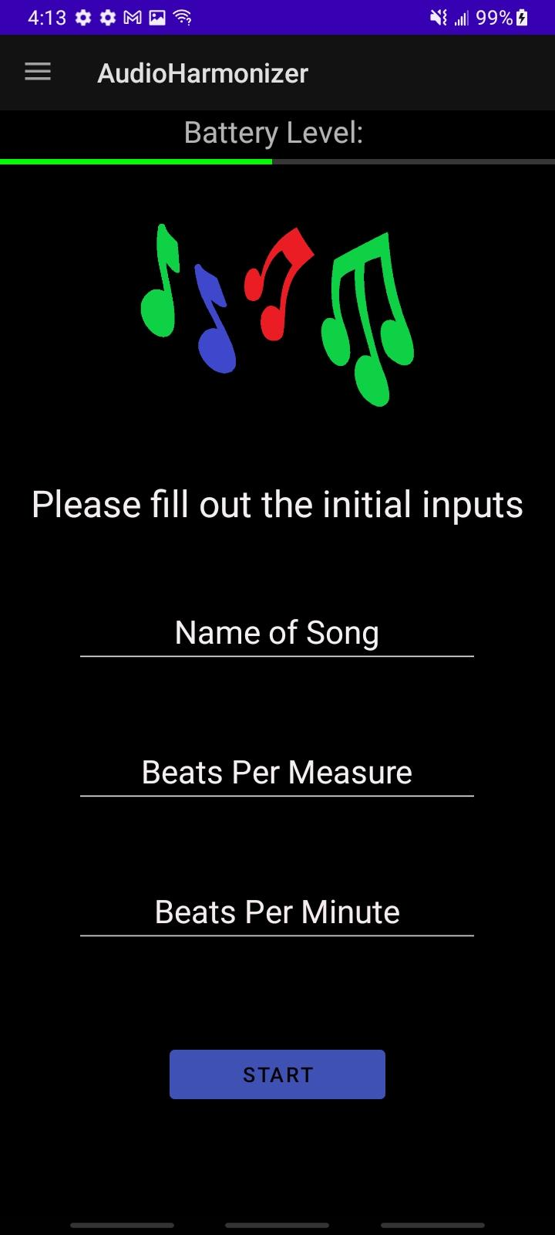

*Output Snippet 4.2.3.1: Initial Inputs Page*

### Modes of Operation Page

This page allows the user two make a selection between the two modes of operation. There are 2 buttons on the page, one is labeled automatic, and the other labeled manual.

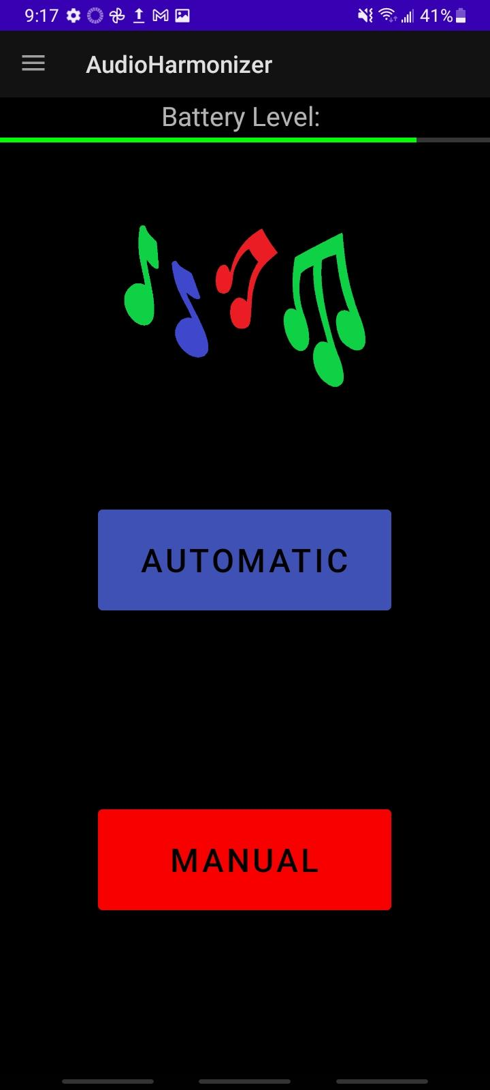

*Output Snippet 4.2.1.1: Mode of Operation Page*

### Automatic Page

There are 5 possible inputs to be sent to the audio harmonizer from this page. The first is the number of additional harmonies and the rest of them are the different chord progressions.

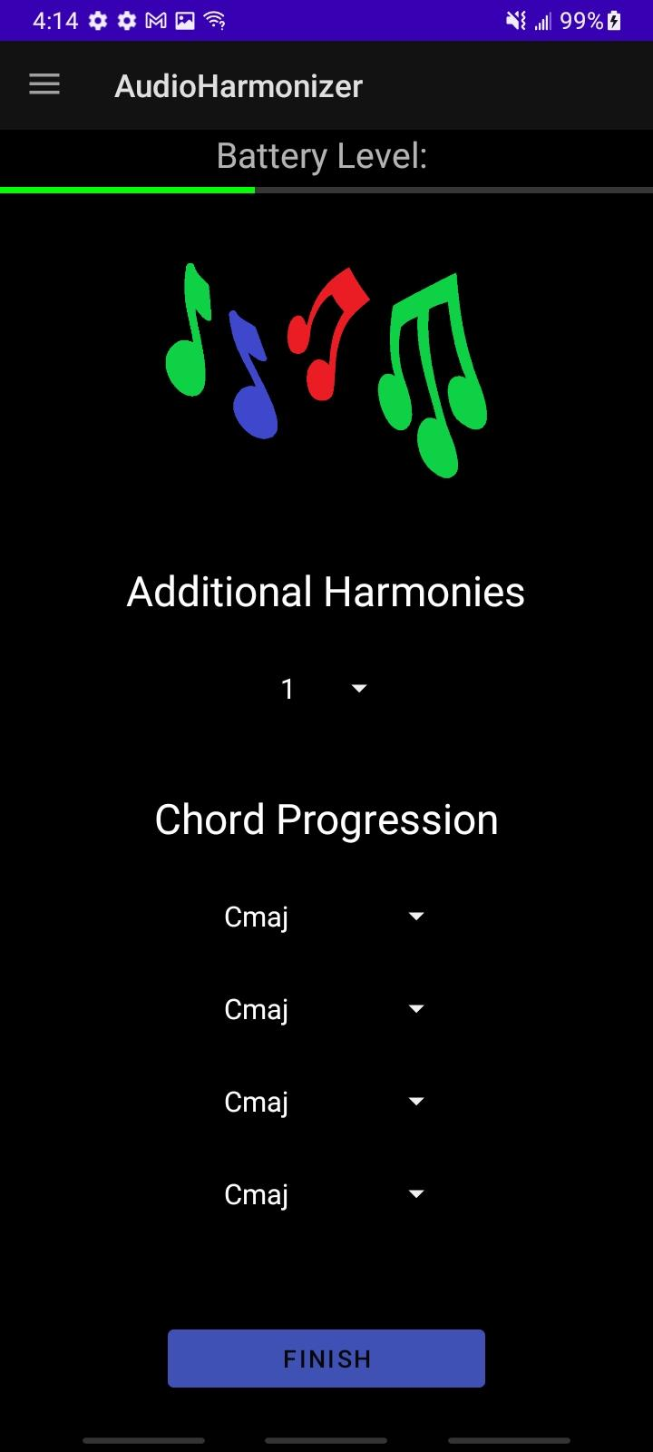

*Output Snippet 4.2.5.1: Automatic Page*

### Manual Page

The manual page has a changing amount of input dropdowns based on user input. The two inputs necessary are the number of harmonies and the number of note, octave, and length pairs per harmony. After those are put in, the user clicks generate to create the additional dropdowns on the page. This page is scrollable so it can handle a large amount of harmonies and notes, octave, and length pairs. Once the user is satisfied with their inputs, they can click finish to move onto the next page.

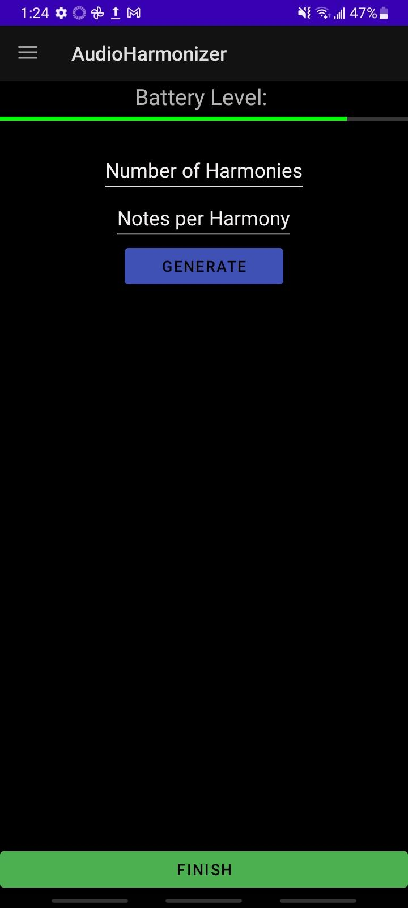

*Output Snippet 4.2.6.1: Manual Page*

### Start Singing Page

The start singing page contains a button that starts a countdown timer and sends a signal to the MCU to start the audio harmonizer. It also contains a stop button which sends a signal to the audio harmonizer to stop running.

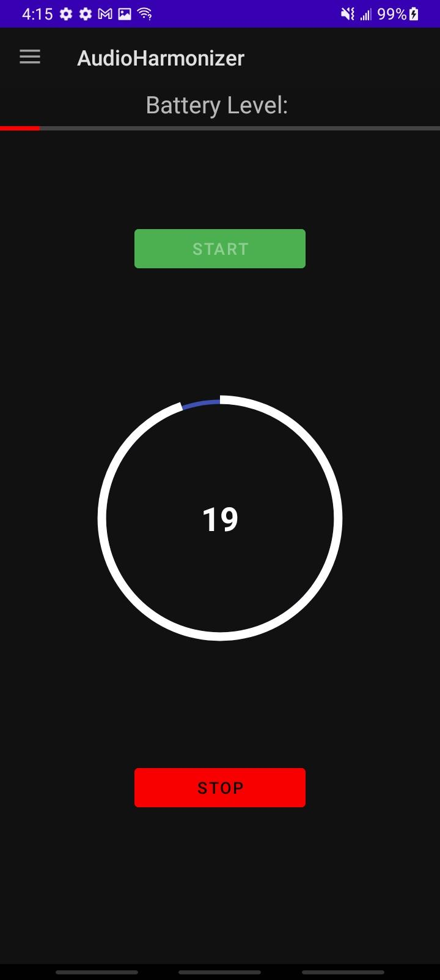

*Output Snippet 4.2.7.1: Start Singing Page*

## Validation

Link to demo of bluetooth connection: <https://www.youtube.com/watch?v=IBHxdSgLK58>

### Navigation Bar

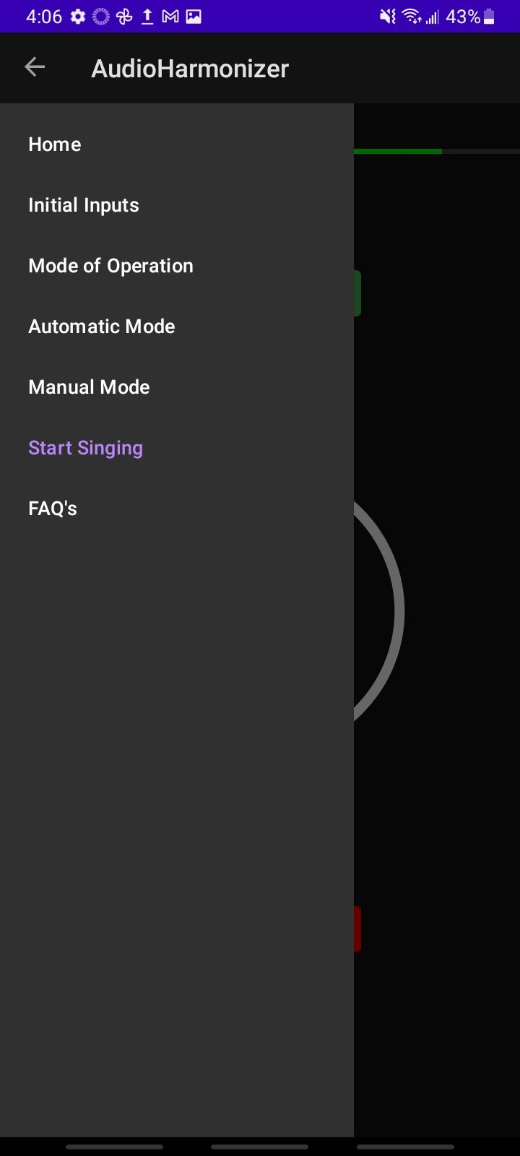

*Output Snippet 4.3.1.1: Working Navigation Bar*

As seen in figure 4.3.1.1, the navigation bar is working as expected. The toggle works correctly and is able to open and close on every page. The user can also access all of the necessary pages as needed and doing so will create a new instance of that page.

### Manual Page

The manual page must allow the user to to input the number of harmonies as well as the number of note, octave, and length pairs per harmony. Depending on the input the manual page should create X number of harmonies and Y number of note, octave, and length pairs per harmony.

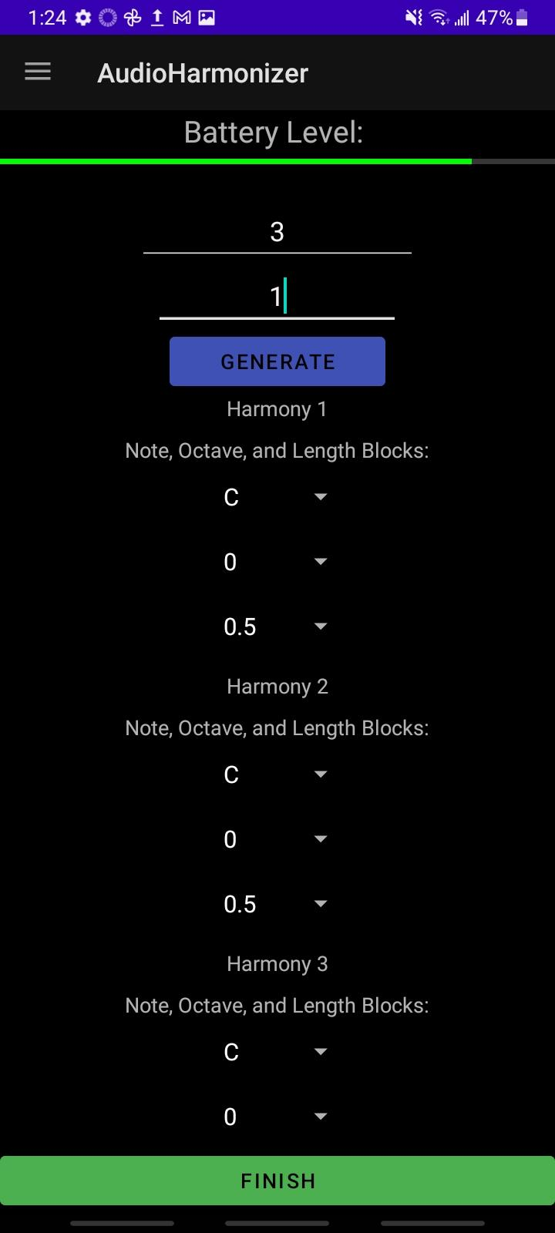

*Output Snippet 4.3.2.1: Manual Example Output 1*

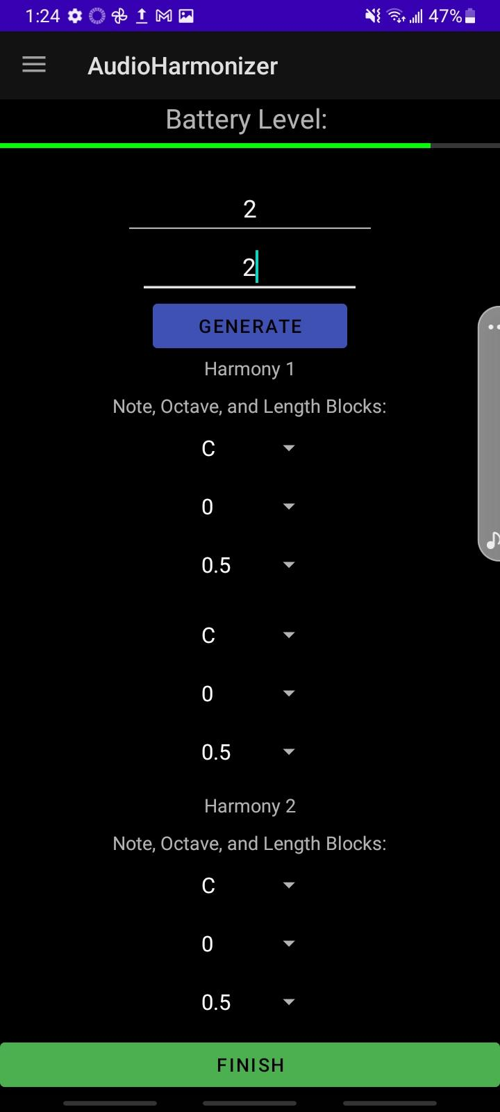

*Output Snippet 4.3.2.2: Manual Example Output 2*

From the figures above you can see 3 different screenshots of the manual page working. Figure 4.2.6.1 is an example of the page before the user has put any inputs in. Figure 4.3.2.1 is an example of 3 harmonies and 1 note, octave, and length pair. Figure 4.3.2.2 is an example of 2 harmonies and 2 note, octave, and length pairs.

### Application only connects to one device

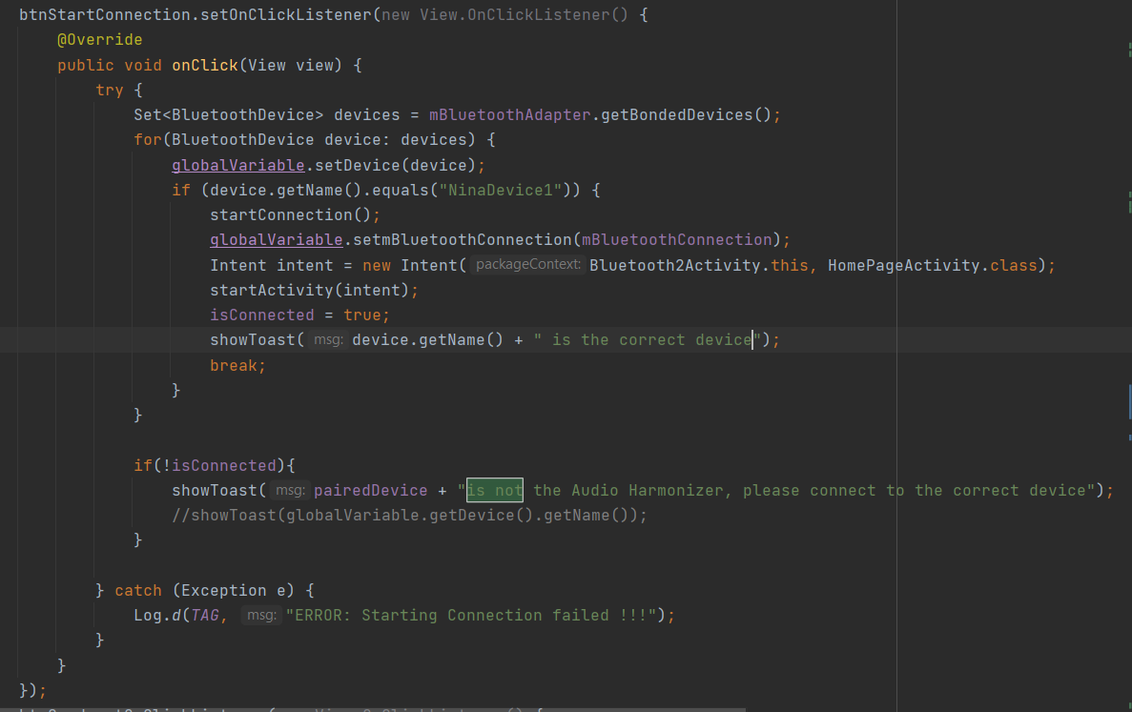

*Code Snippet 4.3.5.1: Start Connection button*

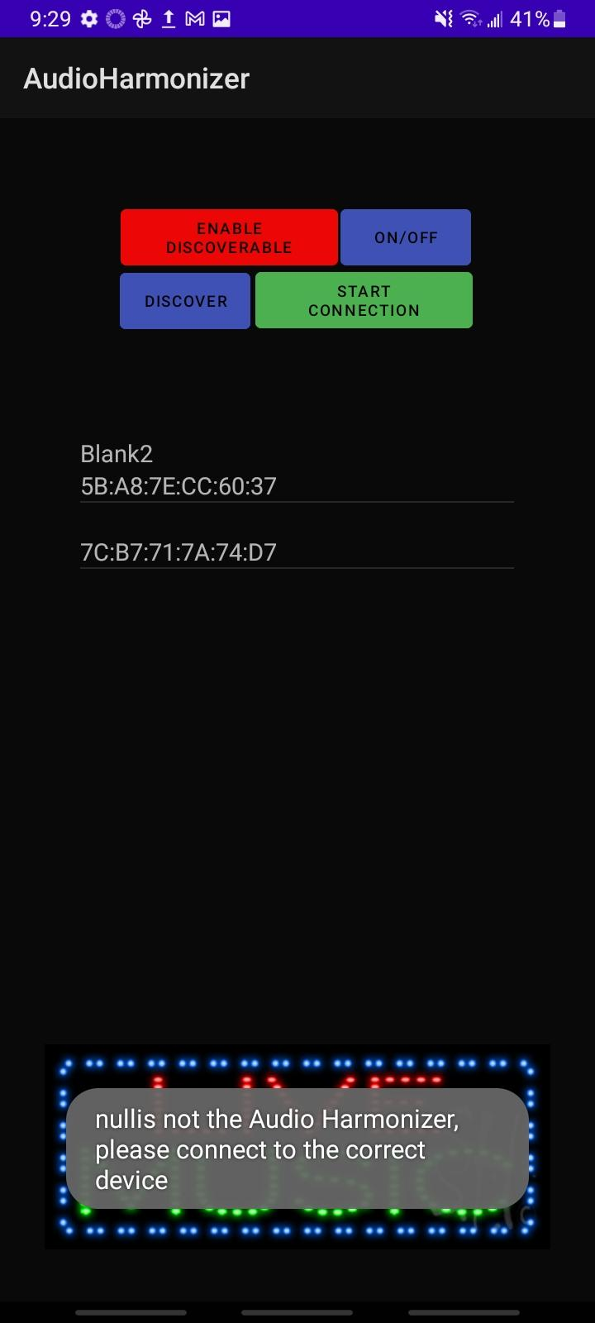

*Output Snippet 4.3.5.2: Wrong Device connected*

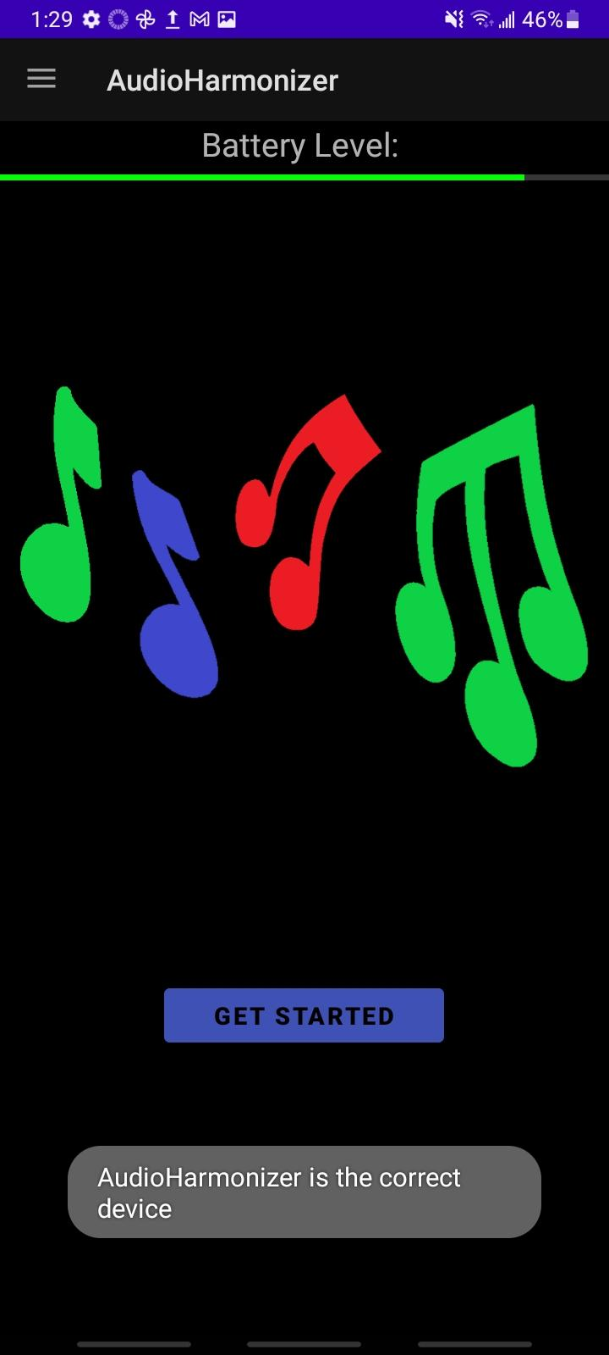

*Output Snippet 4.3.5.3: Correct Device Connected*

In figure 4.3.5.1 the code loops through each device once the start connection button is pressed. The name of the correct device is hardcoded into the application. To validate this, the correct device was set to AudioHarmonizer. In figure 4.3.5.2 the wrong device was paired, and the name did not match so the application threw the error message that it was not the correct device. In figure 4.3.5.3, AudioHarmonizer was selected and the device led the user to the home page of the application as required.

### Bluetooth Disconnection

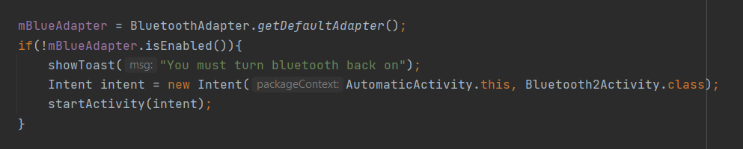

*Code Snippet 4.3.6.1: Bluetooth Disconnection Code*

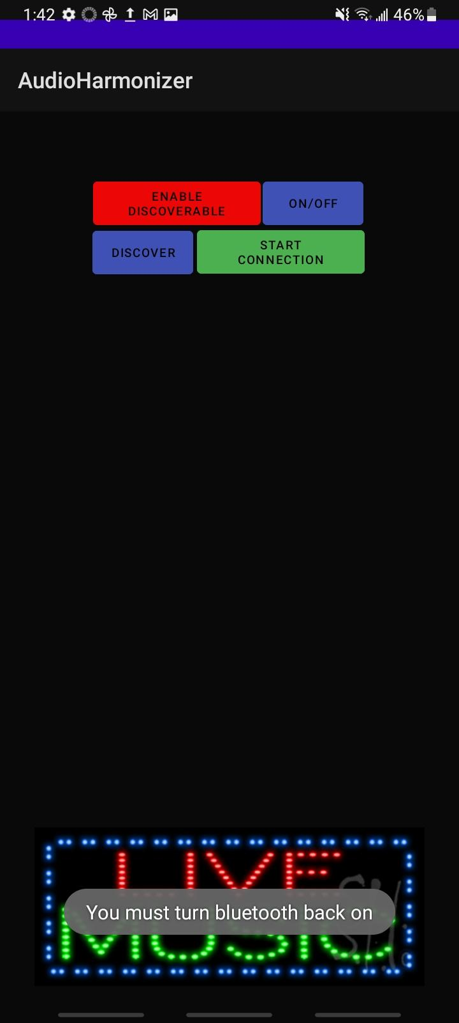

*Output Snippet 4.3.6.2: Bluetooth Disconnection Output*

This snippet of code from figure 4.3.6.1 is on every page of the application. Just replace the first argument of the intent with the appropriate page title. It checks if bluetooth is enabled and if not, it will take the user straight back to the bluetooth page where they will be required to turn on bluetooth and establish a connection again before continuing. The message “you must turn bluetooth back on” is shown whenever this happens as seen in figure 4.3.6.2.

### Sending Data - User Inputs

` Automatic Mode:

The application is able to connect to the MCU via bluetooth to send data. To validate this, below are screenshots of the terminal of the Android App and the MCU. In figure 4.3.5.1, the outputs selected by the user were written out to the terminal. In figure 4.3.5.2 it is evident that those same inputs were received in the MCU terminal.

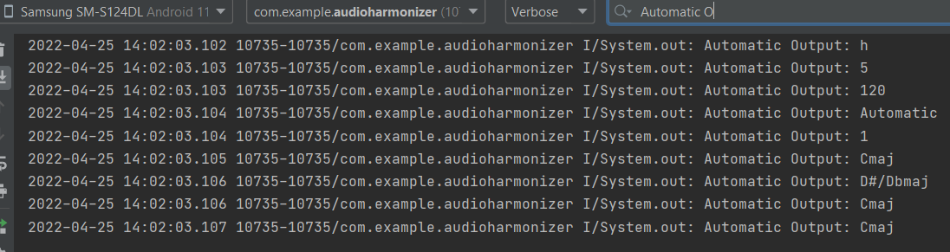

*Output Snippet 4.3.5.1:Android Automatic Output*

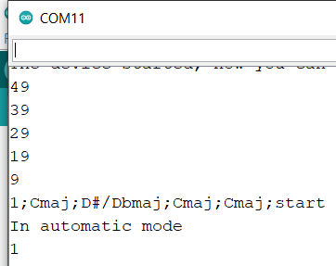

*Output Snippet 4.3.5.2: MCU Automatic Output*

Manual Mode:

Below are screenshots of the terminal of the Android App and the MCU. In figure 4.3.5.3, the outputs selected by the user were written out to the terminal. In figure 4.3.5.4 it is evident that those same inputs were received in the MCU terminal.

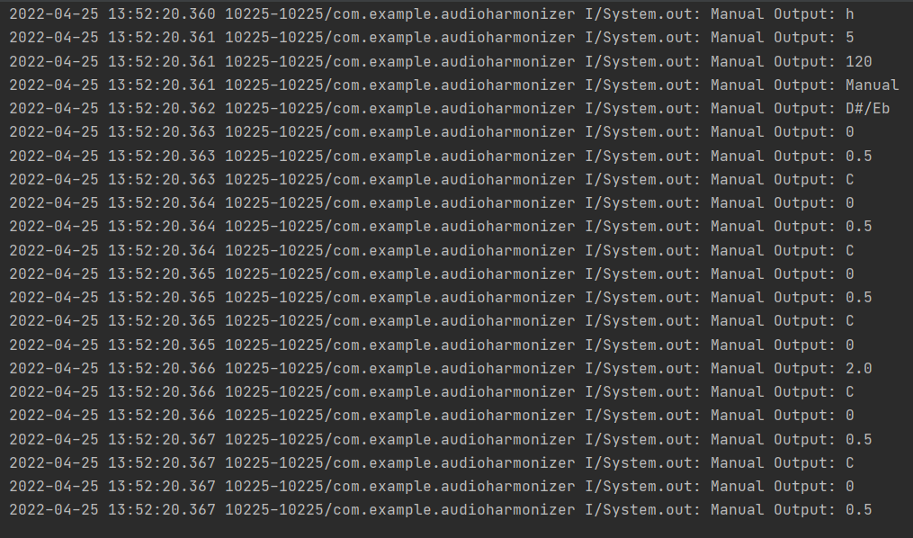

*Output Snippet 4.3.5.3: Android Manual Output*

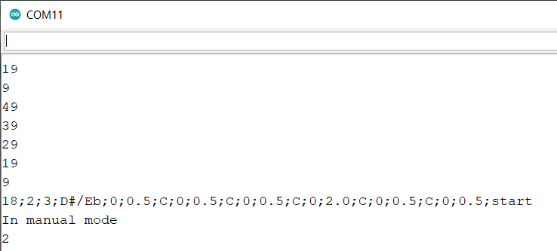

*Output Snippet 4.3.5.4: MCU Manual Output*

### Receiving Data - Battery Level

Below are screenshots of the terminal of the Android App and the MCU. Figure 4.3.6.1 shows the battery percentages sent from the MCU terminal on the left side. Those are sent to the Android app and received. On the right side, it is evident those same inputs from the MCU were received in the Android terminal.

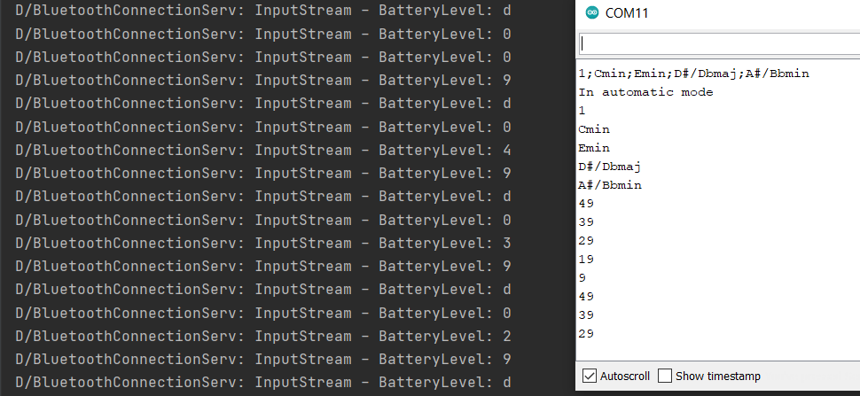

*Output Snippet 4.3.6.1: Android & MCU Battery Level Output*

## Conclusion

The subsystem is working as expected and provides all the necessary support to the other subsystems. With the bluetooth communication validated, the subsystem is able to take in user inputs for both manual and automatic modes of operation and send them to another device via bluetooth. The Android application is complete and is essential to the functionality of the Audio Harmonizer.

Audio Harmonizer

Urinrinoghene Lauretta Omughelli

# **Full System/InterSystem Report**

REVISION – Final Report

December 5th, 2021

Table of Contents

**Full System/InterSystem Report** **10**2

**Introduction** **10**4

**MCU and Android App Bluetooth Communication** **10**4

**DSP and MCU I2C Communication** **10**4

Introduction 104

Execution 105

Validation 105

**Main PCB** **10**6

Introduction 106

Execution 107

Validation 107

**Main PCB and Power Supply** **10**7

Introduction 107

Execution 107

Validation 107

**Full System Description and Development** **1**08

Overview 108

Execution 108

Validation 109

**Conclusion** **1**09

# Introduction

Ecen 404 was spent integrating and validating each subsystem and the inter-subsystem functionality to ensure that the full Audio Harmonizer System was successful. Below is the execution of how each subsystem was connected within the Audio Harmonizer and the validation to showcase that the subsystems were able to successfully communicate with each other for the Full System Integration.

# MCU and Android App Bluetooth

## Introduction

The MCU and Android App bluetooth communication was responsible for relaying the battery levels to the app and the type of harmonizing and stop/start commands to the main PCB's DSP.

## Execution

This communication was successful and performed as intended as all battery levels were communicated seamlessly to the app. Also, the DSP received all data and started and stopped audio when intended.

## Validation

Please reference the Android Application subsystem report to see full validation.

# DSP and MCU I2C Communication

## Introduction

The DSP subsystem received user inputs from the MCU (that were relayed from the Android Application). The MCU sends a single 8 bit integer value at a time to the DSP and the DSP code stores the values in the order it was received. The values are sent over I2C Communication with a connection for data, clock, and ground. Below is the function used on the ESP32 to send data over I2C to the MSP430 and part of the I2C Interrupt Function on the MSP430 that stored the correct values to the proper variables (the rest of the function is similar if statements but is too long to show in a screenshot).

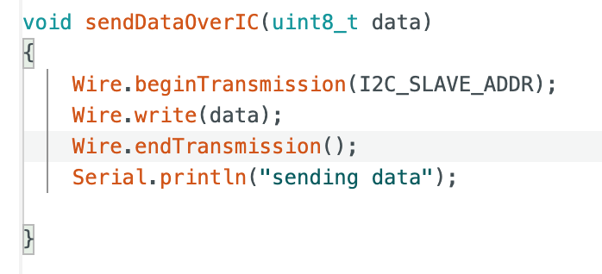

*Code Snippet 3.1.1: ESP32 I2C Communication with DSP*

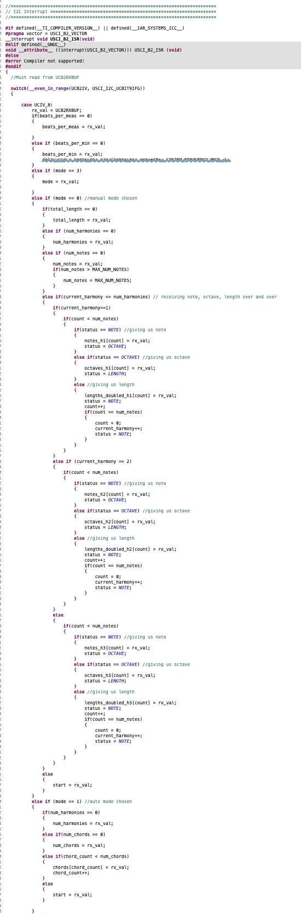

*Code Snippet 3.1.2: MSP430 I2C Interrupt Function Section*

## Execution

The ESP32 was successfully able to send the user inputs from the Android Application to the MSP430.

## Validation

Using the debugger on Code Composer Studio, we were able to see what values were stored on the MSP430 (DSP subsystem) from the I2C Interrupt Function. Below are screenshots of the inputs received.

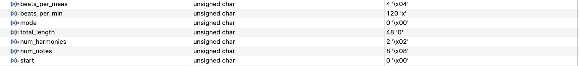

Output Snippet 3.3.1: MSP430 Receiving Inputs Part 1

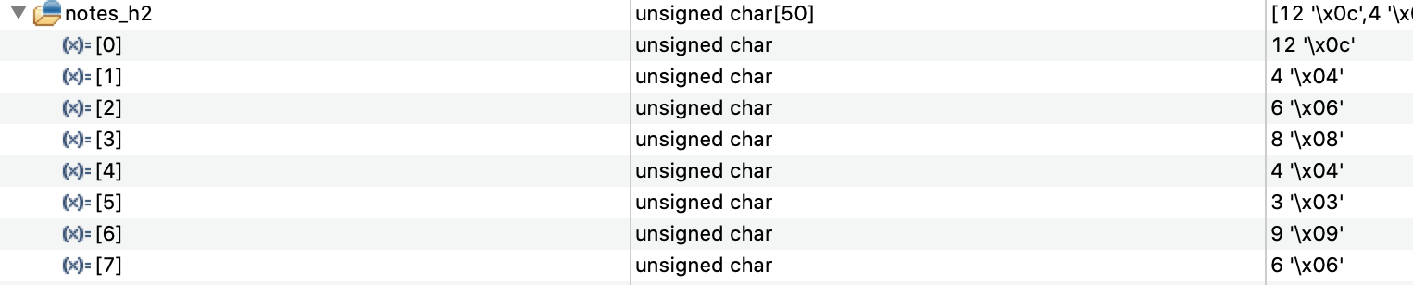

Output Snippet 3.3.2: MSP430 Receiving Inputs Part 2

# Main PCB

## Introduction

Main PCB consists of the ESP-32(MCU), MSP-430(DSP), DAC, and various audio circuitry and ICs in order to process the audio. The PCB takes in audio via a 3.5mm audio jack and amplifies that with an op-amp that is powered by the MSP-430(DSP). The audio is then sent to the DSP where it is processed and converted to digital with the internal ADC within the DSP. The audio, in digital, is sent out to the external DAC that is amplified with a dedicated audio amplifier chip. This output of the audio amplifier is then sent to the speaker connections. Within this design there is communication between the DSP-MCU, MCU-Android Application, and MCU-Power Supply in both directions. As the MCU can tell the DSP when to start recording and also send various audio processing data to be followed. There are also physical switches or buttons on the board to start/stop audio. Furthermore, the MCU is connected to an external power supply via I2C to communicate the battery levels via bluetooth.

## Execution

Overall the design is successful and works as intended. Audio is sent in via a microphone plugged into the 3.5mm audio jack and outputs to the external speaker via the header pins. The communication with the android application also works as when you select to start the audio processing the board then does so.

## Validation

Please find the below video of the PCB processing the audio with a slight delay in order for testing in the early stages.

<https://github.com/Urinrin-Omughelli/Audio-Harmonizer/blob/5d81e2d85968333d6ce61b22667975525b7e04ad/Demos/PCB%20Board%20Demo.mov>

# Main PCB and Power Supply

## Introduction

The MCU, ADC/DAC, audio circuitry/ICs, and DSP were all placed on the main PCB that was powered via the Power Supply. To ensure that the power supply was powering the full board, a fuel gauge was attached to the power supply and sent the voltage and battery percentage to the ESP32 via I2C.

## Execution

The Fuel Gauge was able to accurately send the voltage (which was converted into a battery percentage function on the ESP32) and powered the board.

## Validation

Below are screenshots of the voltage and current provided by the power supply as read by a voltmeter and from the fuel gauge I2C.

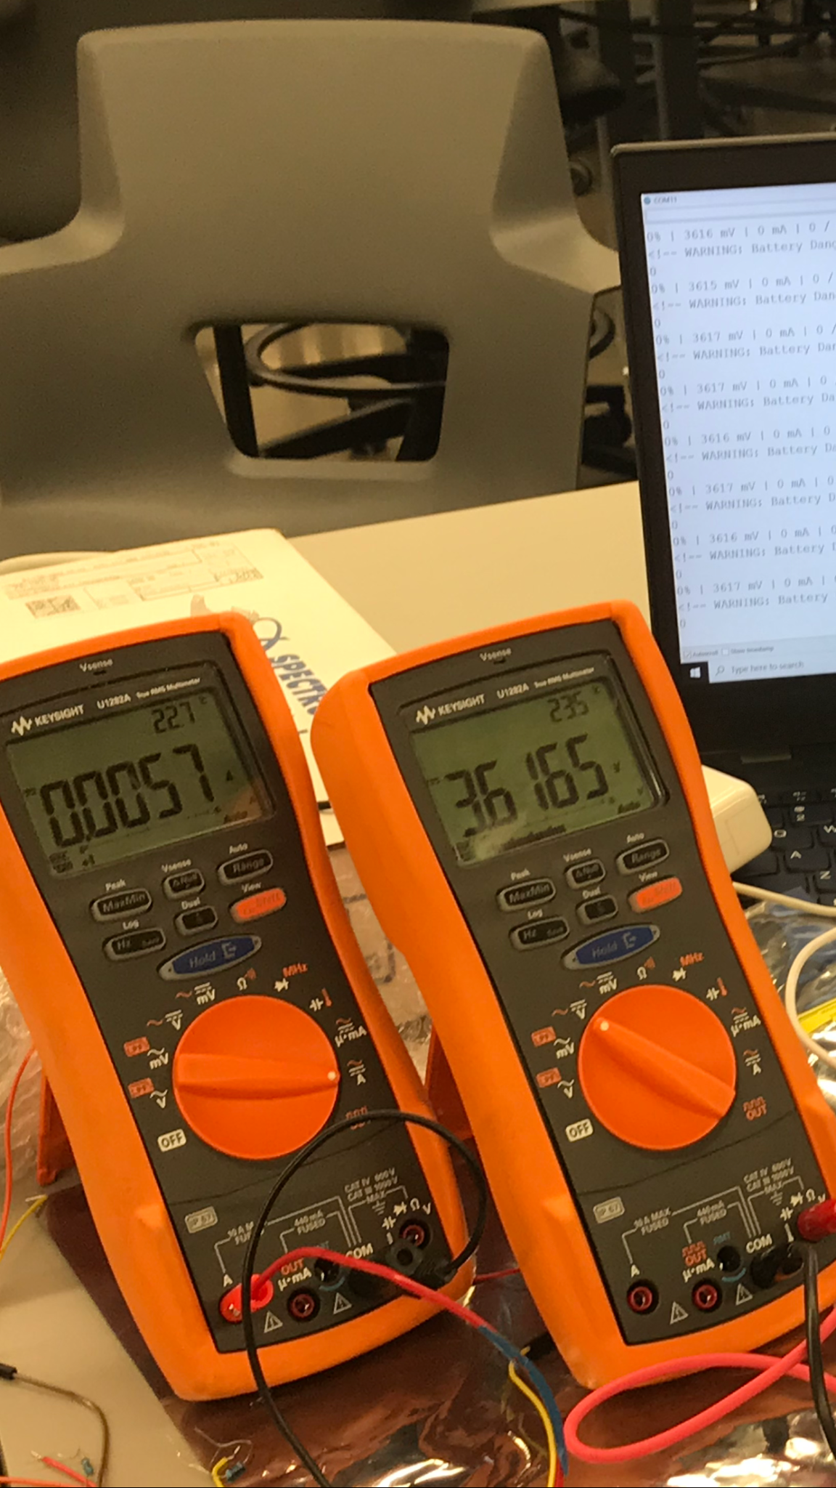

Picture 5.3.1: Voltmeter reading of Power Supply To Verify ESP32 I2C -Voltage Readings

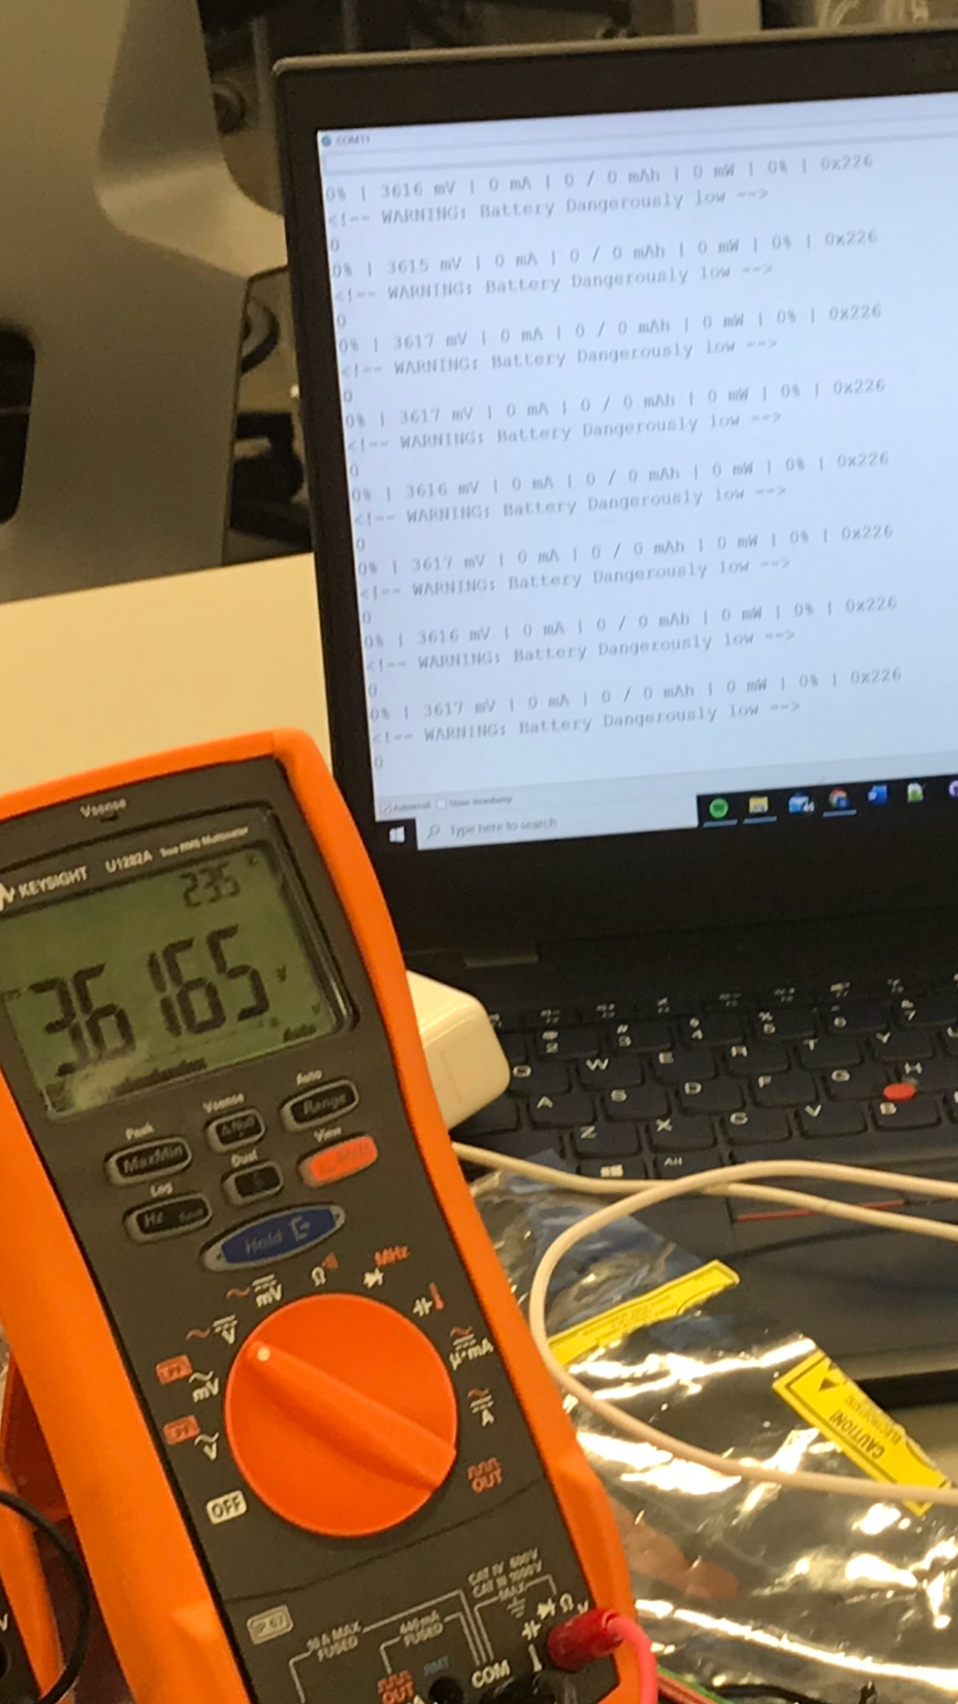

Picture 5.3.2: I2C Fuel Gage Reading from ESP32 of Power Supply Voltage Values.

# Full System Description and Development

## Overview

The Audio Harmonizer ended up successfully integrated with all of the subsystems. Unfortunately, the actual harmony algorithms were unable to be programmed into the DSP but the rest of the functionality did work as expected. If given the chance to recreate this project, with our current knowledge and experience we would be able to properly recreate the system with better hardware that would allow us to meet the initial expectations and requirements of our project.

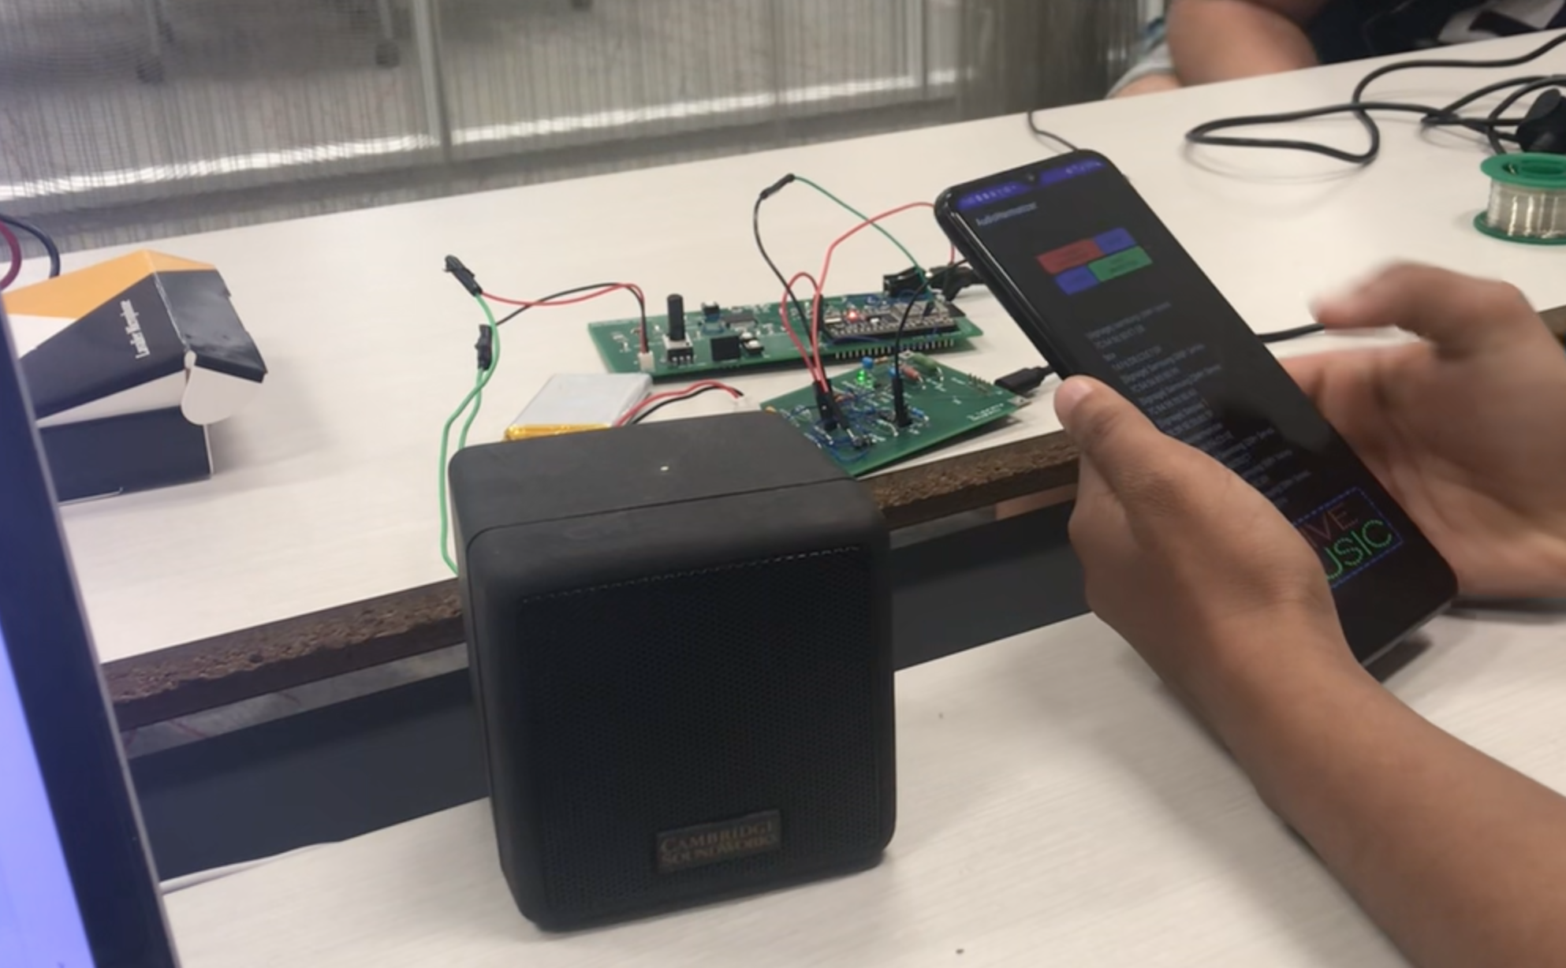

Image 6.1.1: Full System

## Execution

The full system was able to work. We demonstrated that the Android App sends data to the DSP that informs it when to start recording and playing. The speaker began to output the audio coming in from the microphone, and the full system was powered by the rechargeable battery supply. The Android App then sent data to the DSP through the MCU to stop, and was able to do so. Github link to all files regarding the final system:​​ <https://github.com/Urinrin-Omughelli/Audio-Harmonizer>

## Validation

We have a video link showcasing our full system working as expected: <https://github.com/Urinrin-Omughelli/Audio-Harmonizer/blob/main/Demos_PCB_Board_Demo.mov>

# Conclusion

Due to the versatility of audio signal processing the Audio Harmonizer could easily be built for commercial use with a larger budget and timeline. With a stronger signal processor, the Audio Harmonizer could be improved in its ability to handle audio processing in real-time with better audio quality and a more complex note recognition to allow for less precise musicians where pitch may waver.

In addition, improvements upon the quality of the speaker/microphone and battery life set up could allow for performers to use the system at larger venues and concerts. Future versions could also be built to save recordings of the generated harmonies for music production and composition.

The Audio Harmonizer is also capable of expanding its functionality with more complex harmony generation and audio filtering. Signal processing allows for sounds to be manipulated. Incoming audio could potentially be altered to sound like a specific instrument or add a requested effect to the added harmonies per the user’s request.

Due to engineering issues, lack of previous experience with the concepts used in the project, and budgetary/time constraints, we were unable to build the desired product with our initial expectations. However, we were able to create a very similar system with the constraints we did have and proved our initial theory that audio signal processing can be used in conjunction with music theory to create a product that would be useful to independent small artists who are looking for an affordable way to improve performances and that with some integration and designing can be utilized as an affordable product.